|  |  |
| --- | --- |
| Implement Logic gates |  |
| Increment 16 can be implemented using half adders |  |
| PC  /**  * A 16-bit counter with load and reset control bits.  * if (reset[t] == 1) out[t+1] = 0  * else if (load[t] == 1) out[t+1] = in[t]  * else if (inc[t] == 1) out[t+1] = out[t] + 1 (integer addition)  * else out[t+1] = out[t]  */  Bit  /**  * 1-bit register:  * If load[t] == 1 then out[t+1] = in[t]  * else out does not change (out[t+1] = out[t])  */  Register  /**  * 16-bit register:  * If load[t] == 1 then out[t+1] = in[t]  * else out does not change  */ |  |

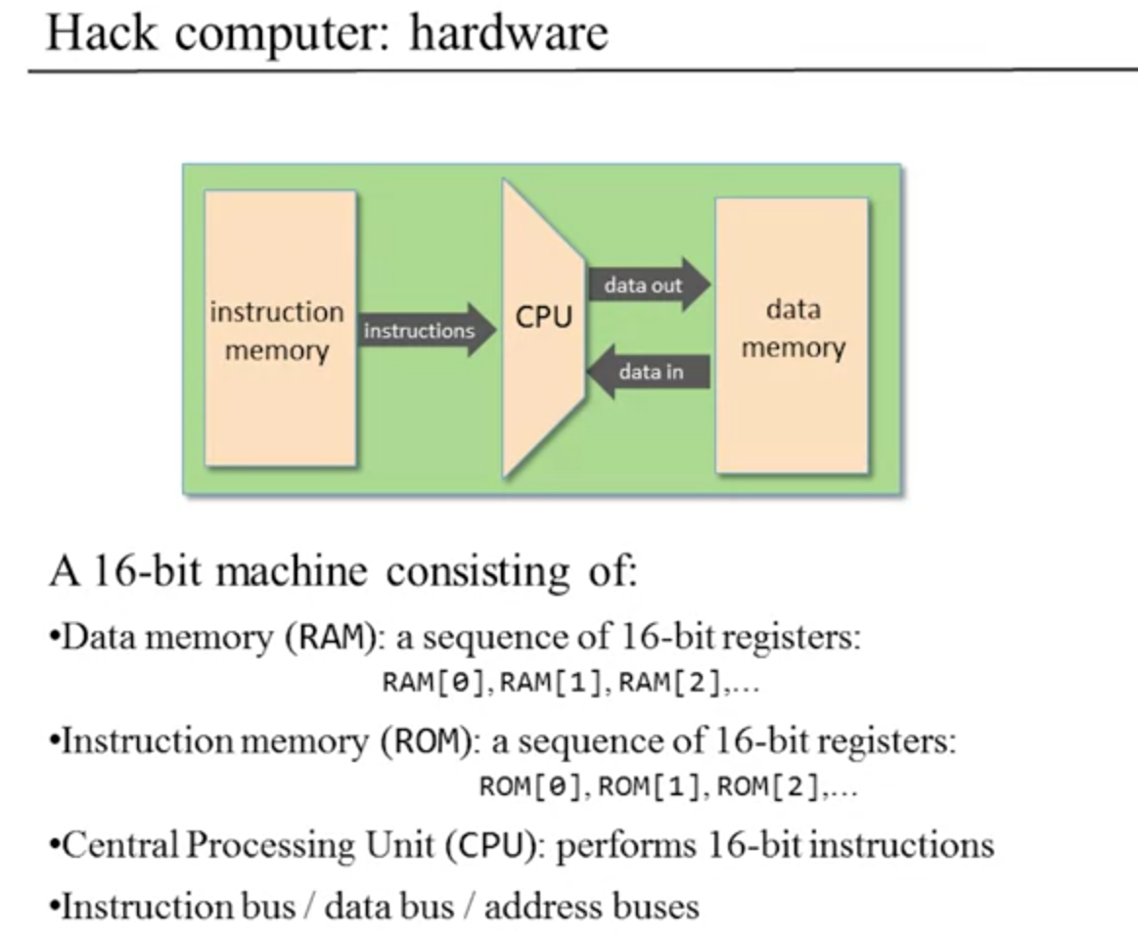

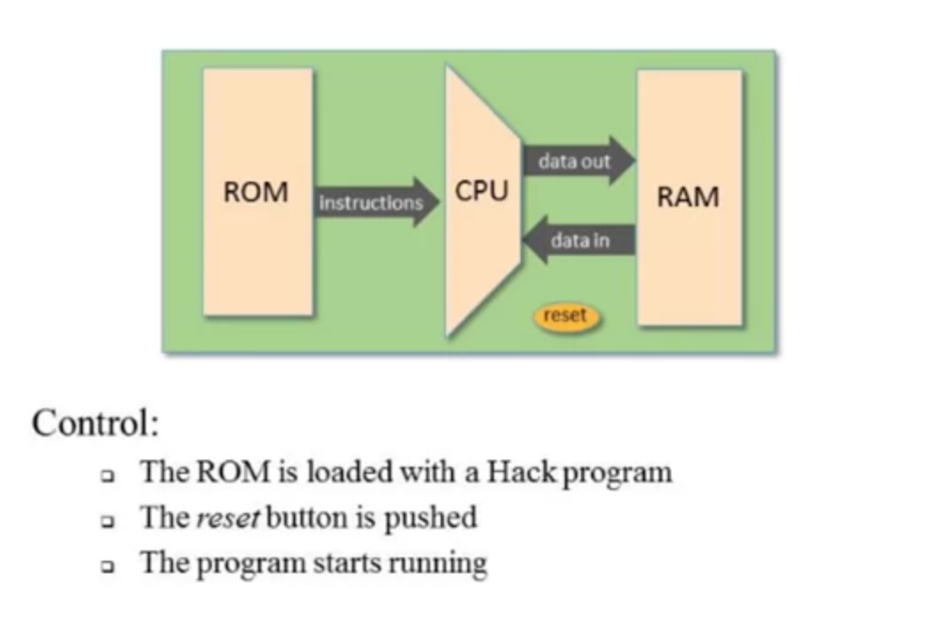

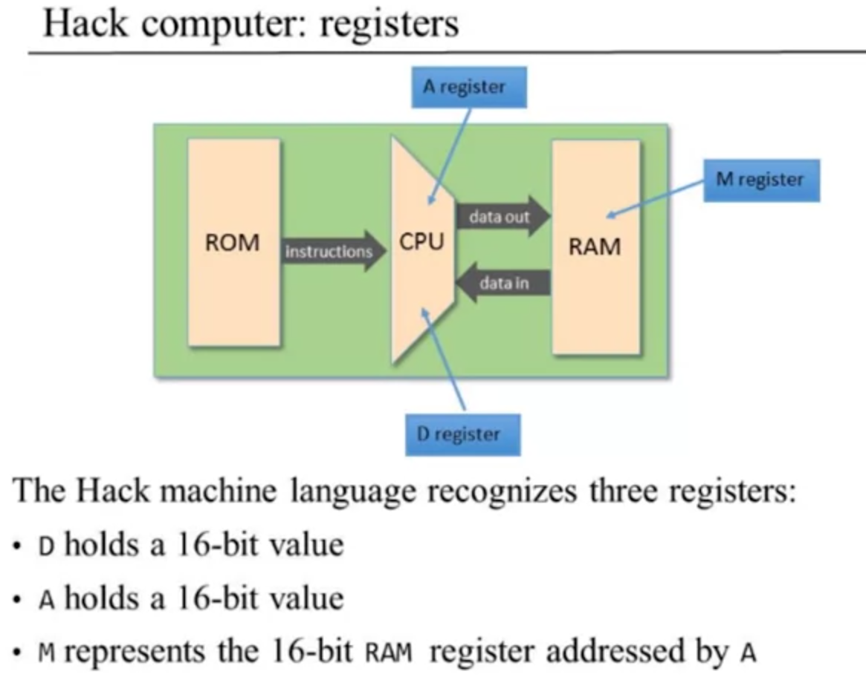

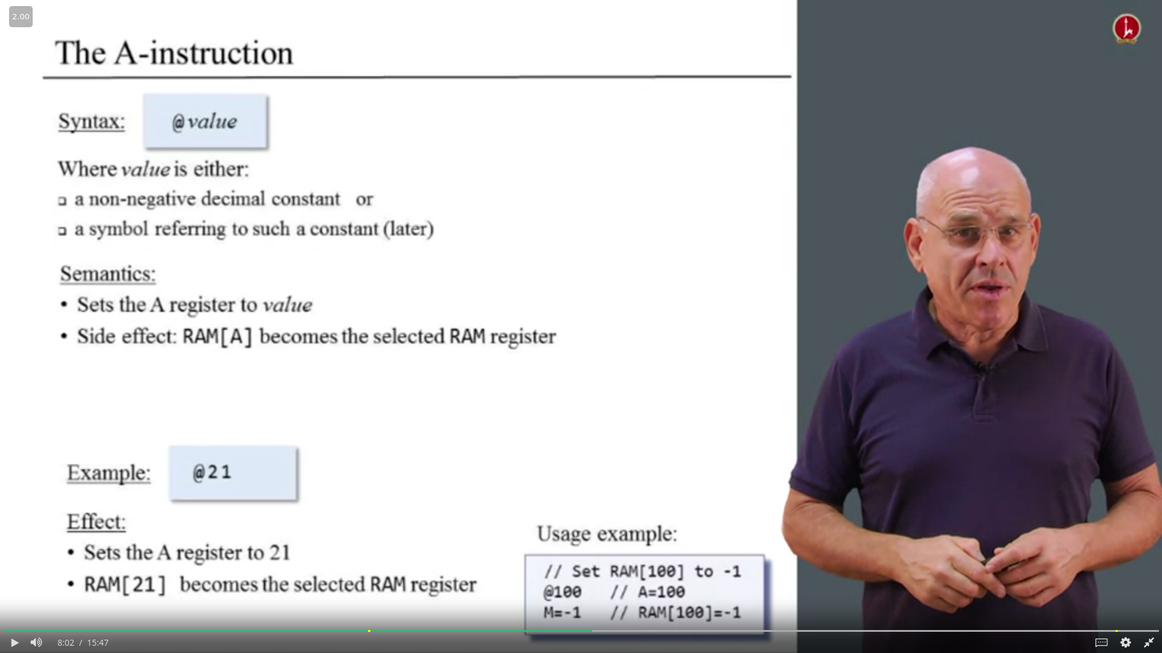

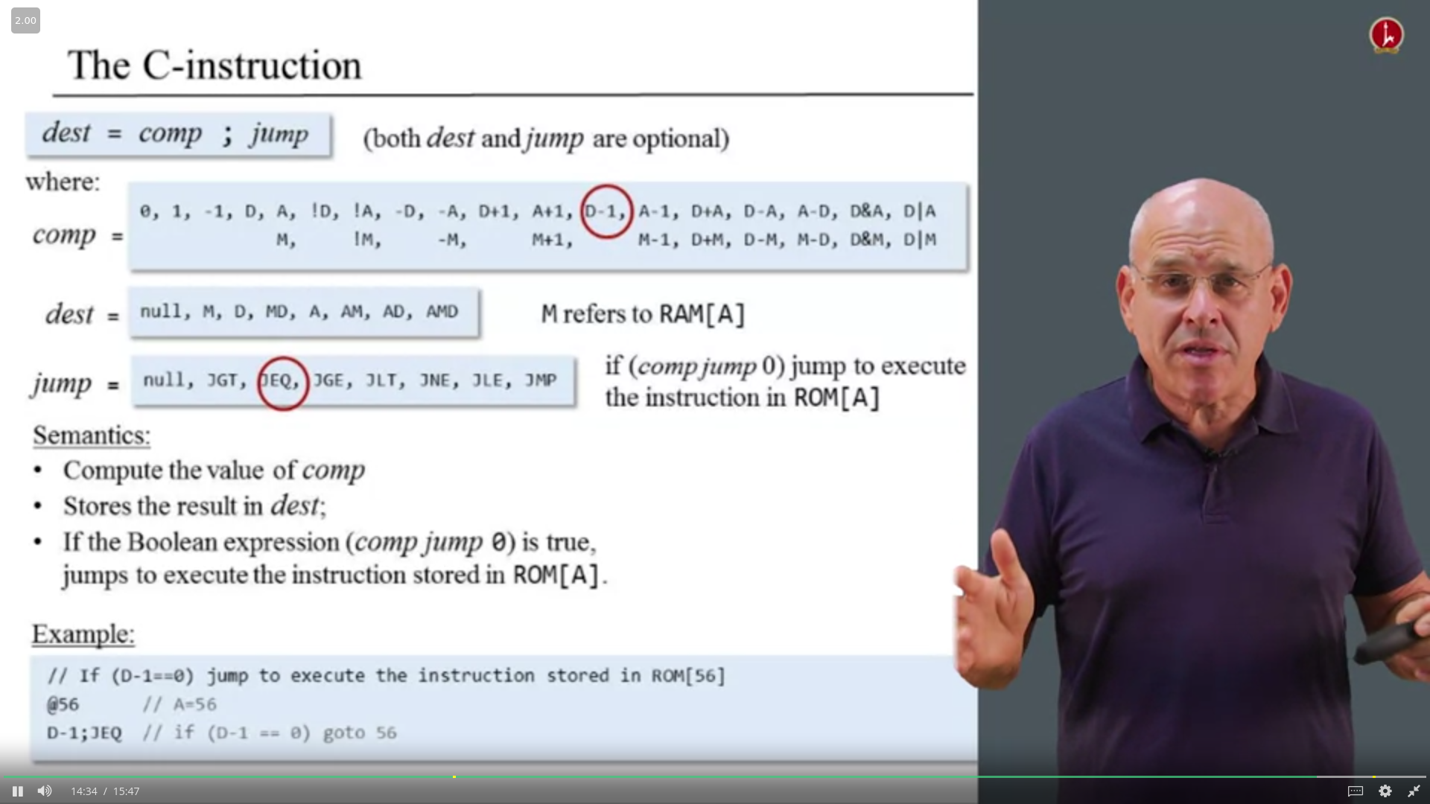

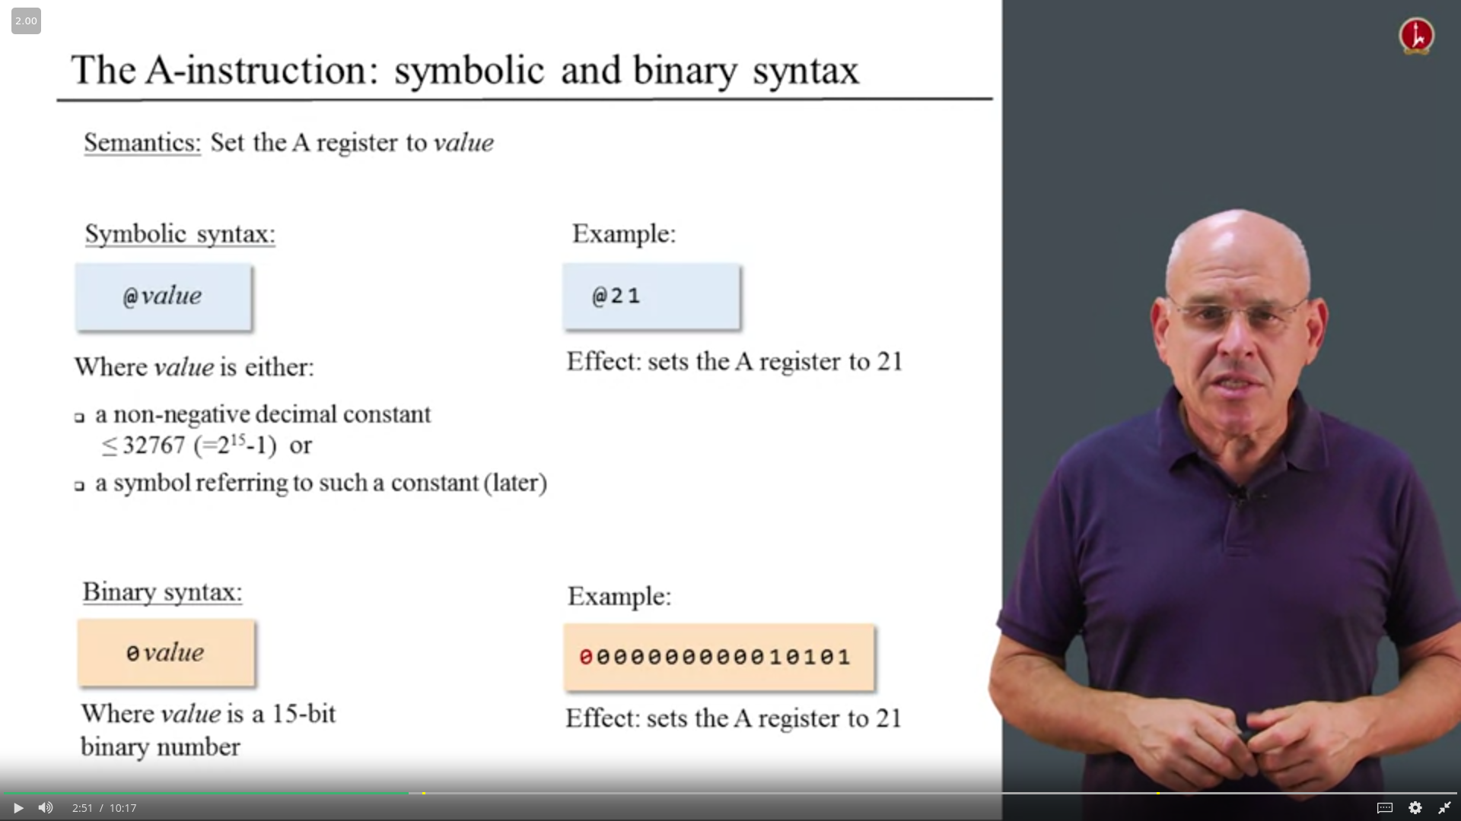

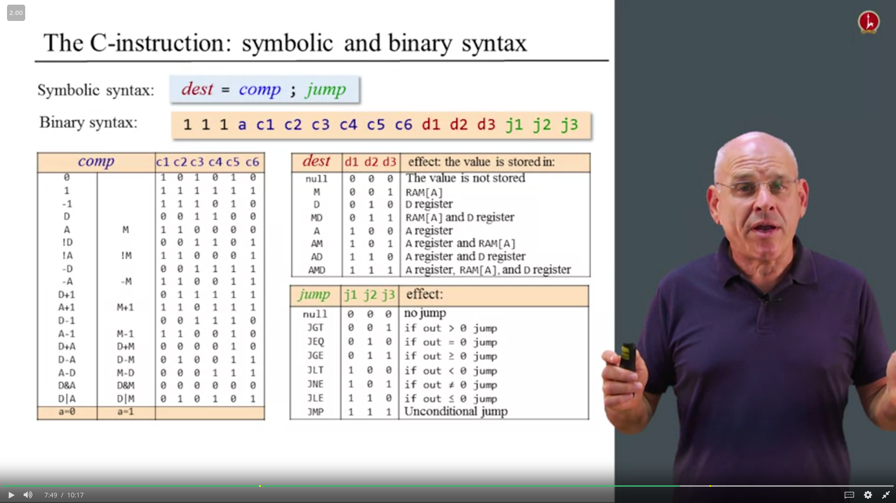

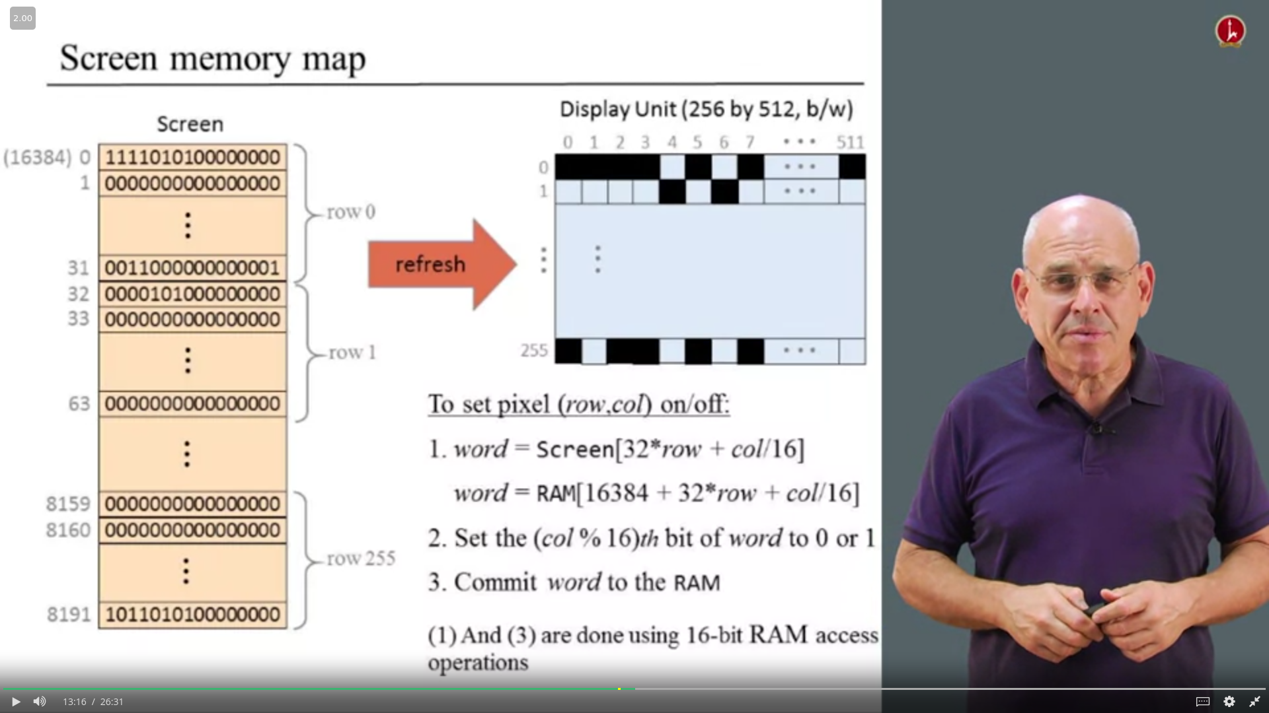

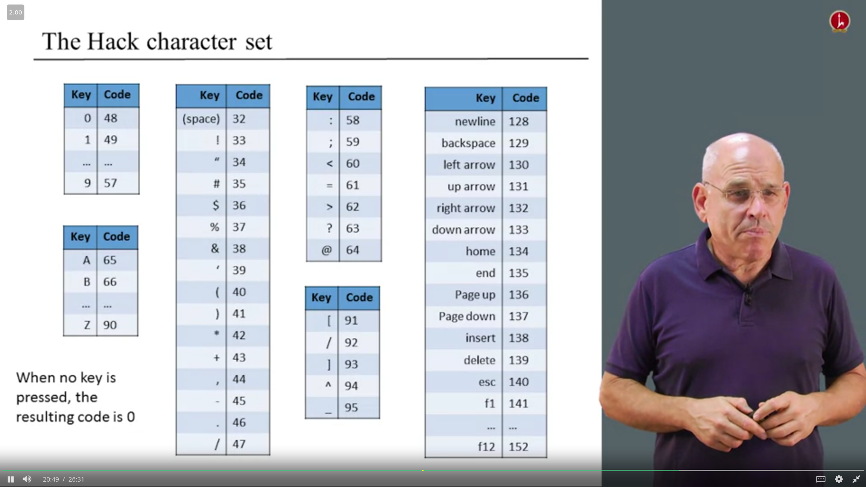

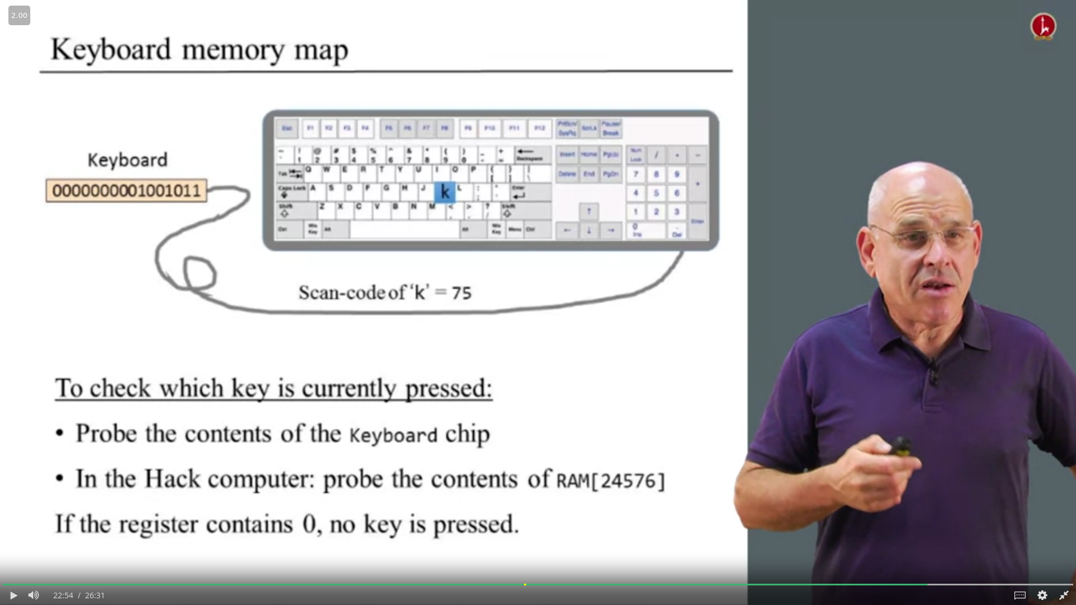

CPUEmulator.sh

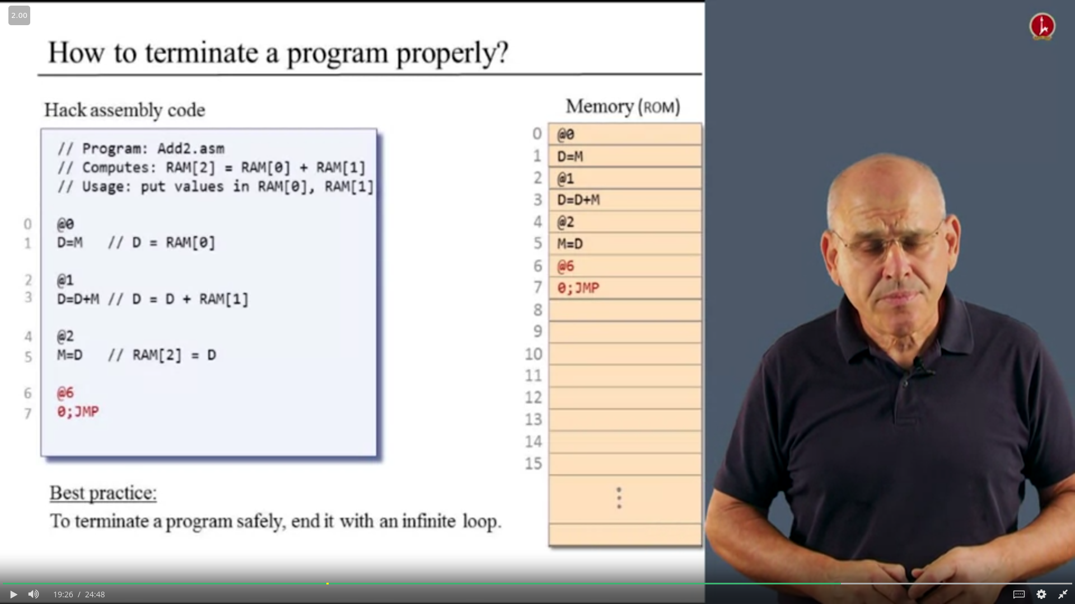

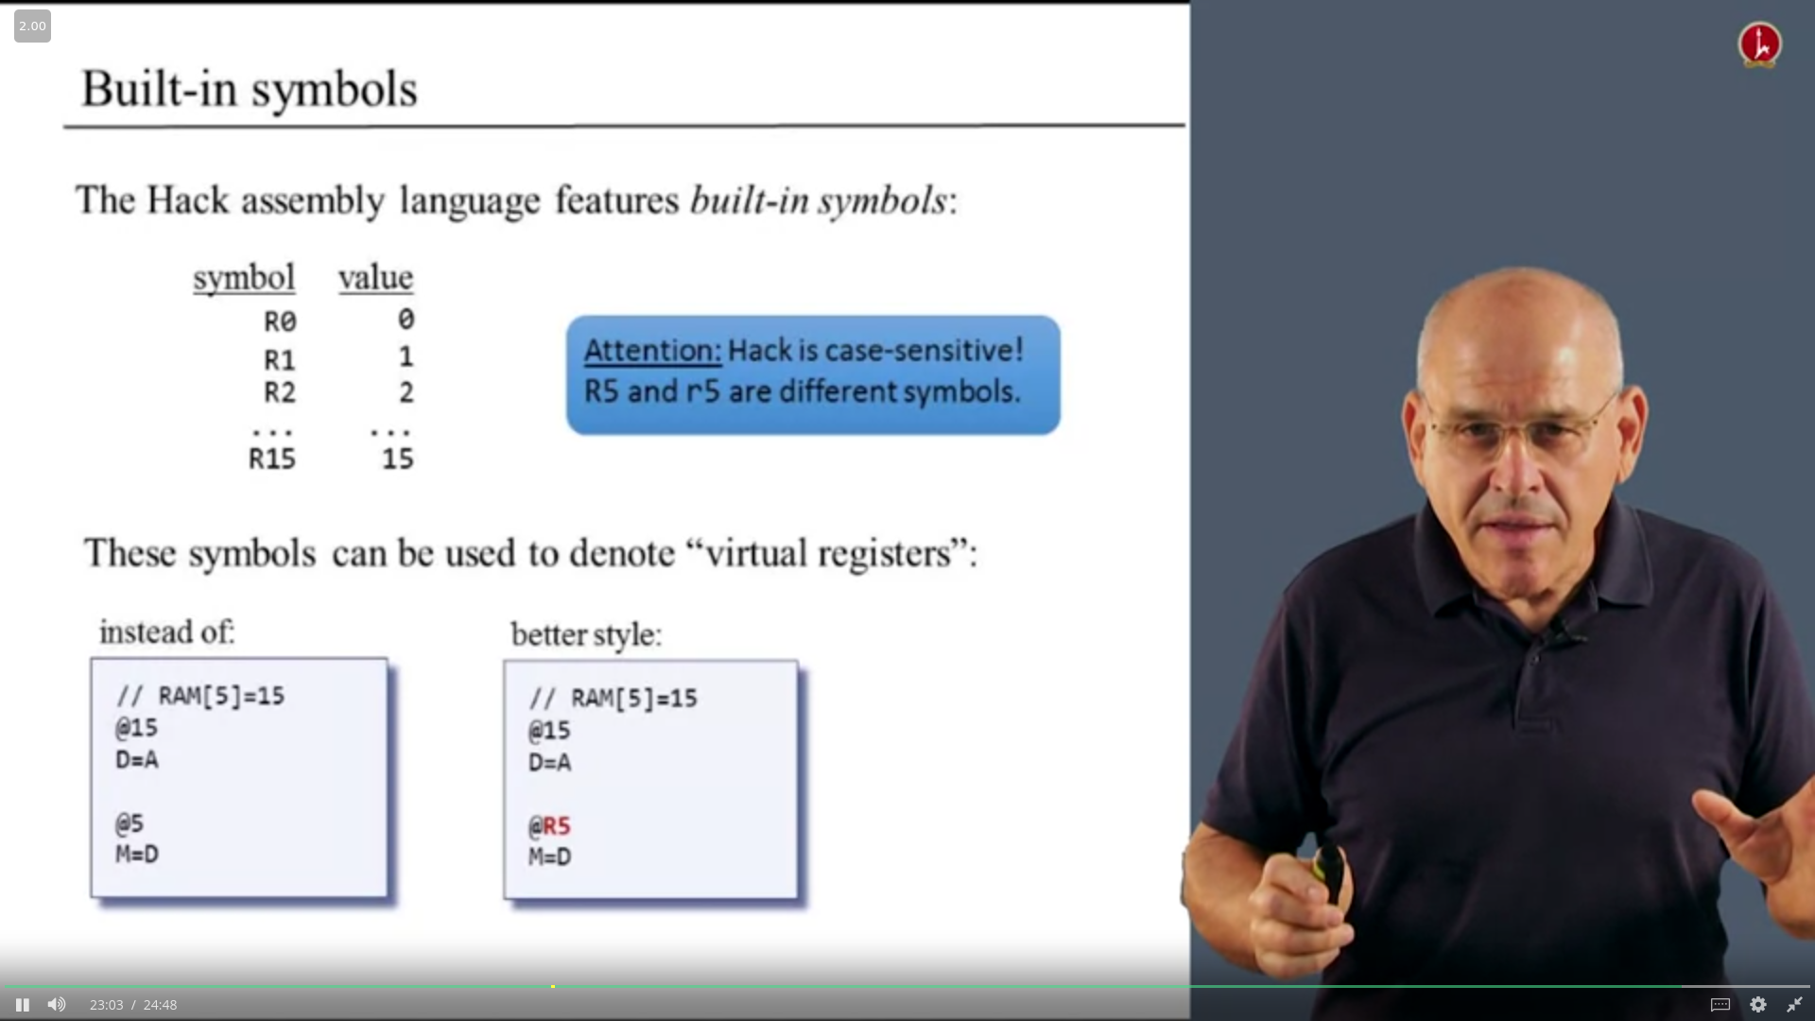

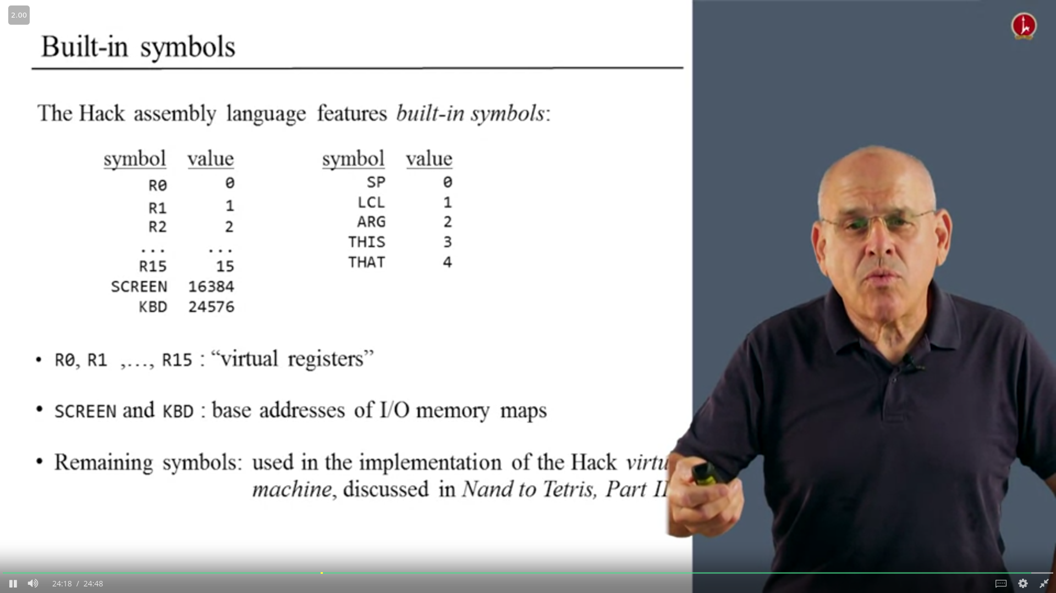

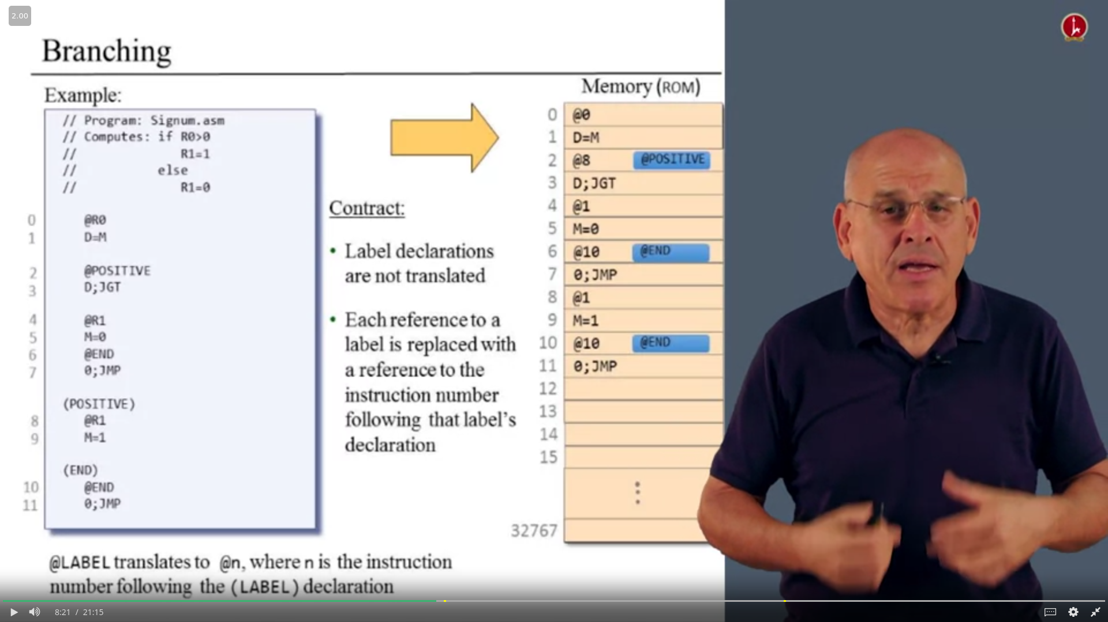

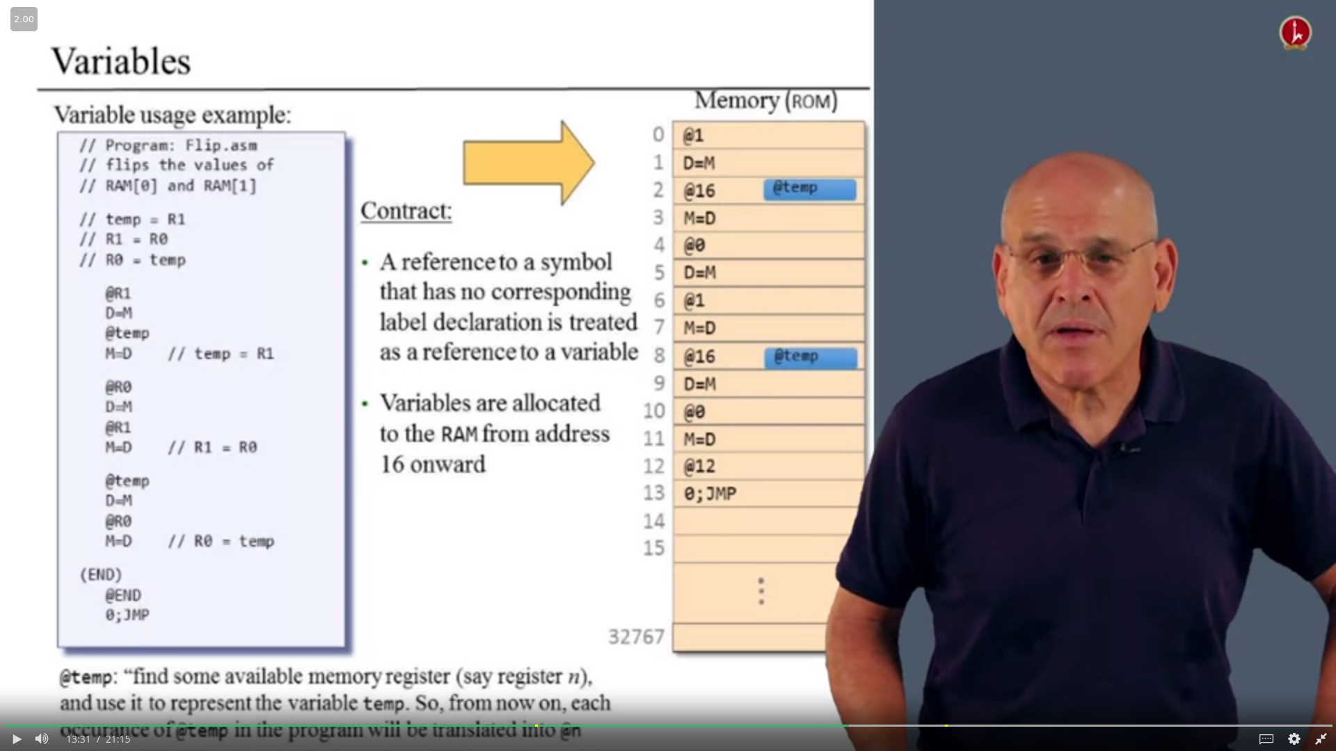

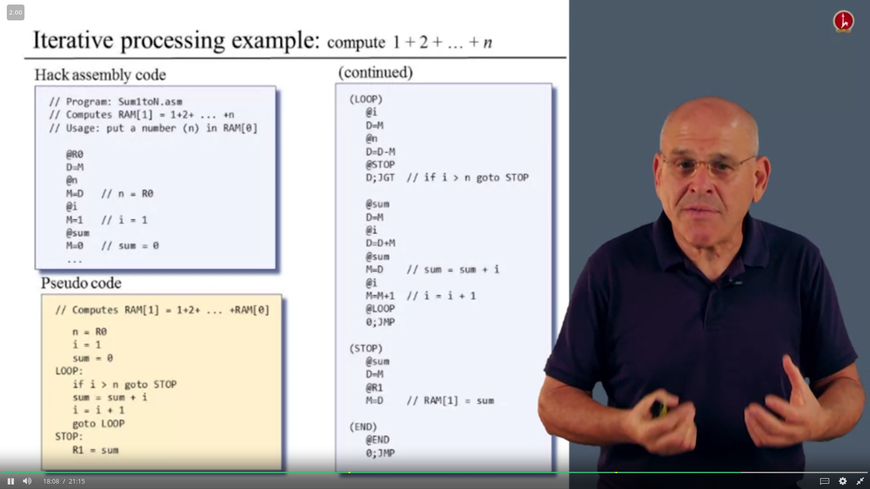

1. Design the program using psuedo code

2. Write the program in assembly language

3. Test the program (on paper) using a variable value trace table

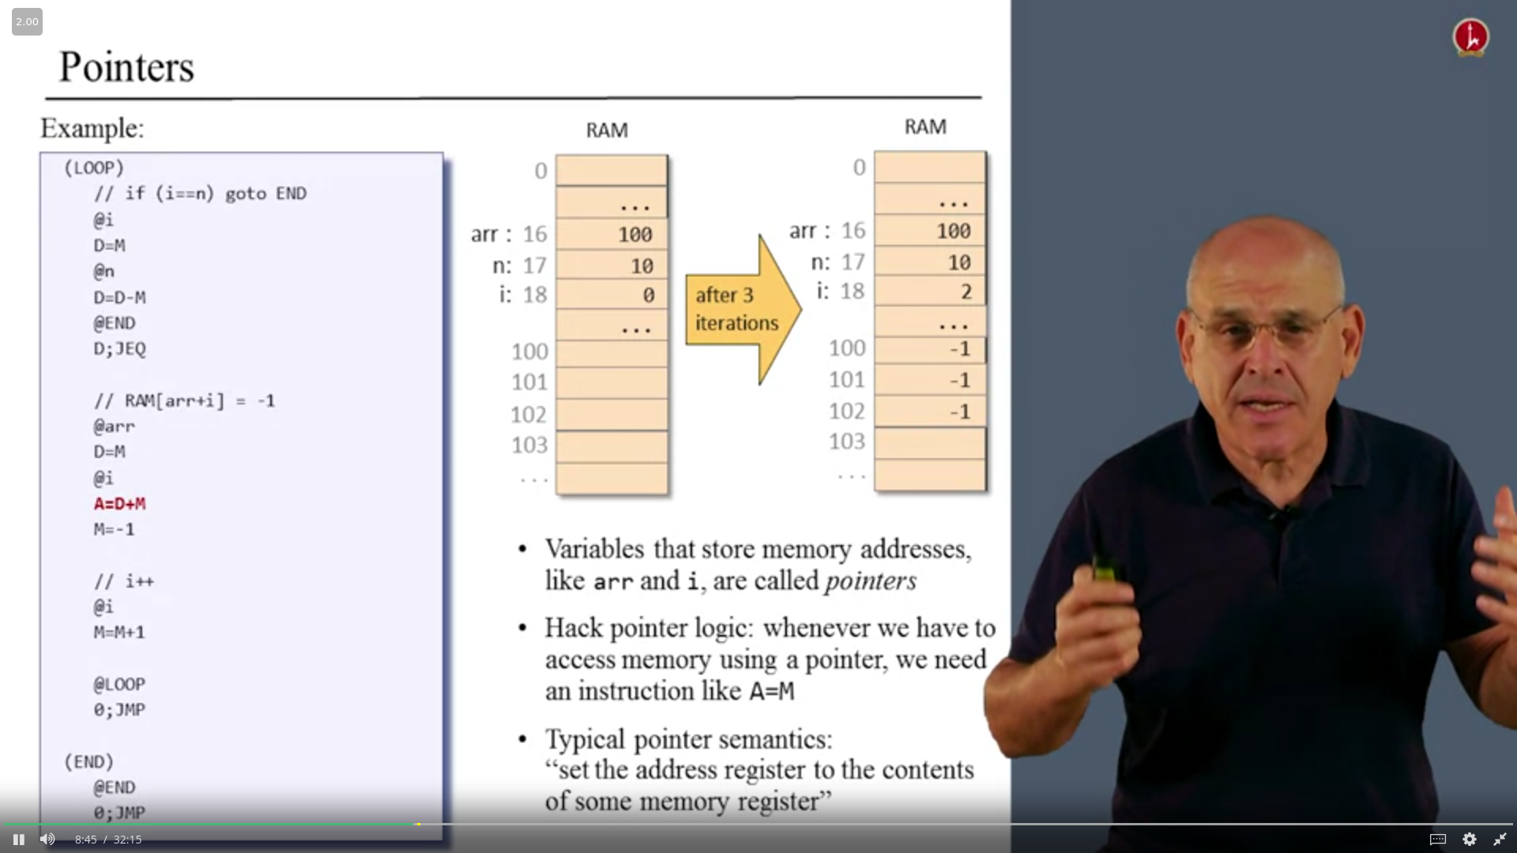

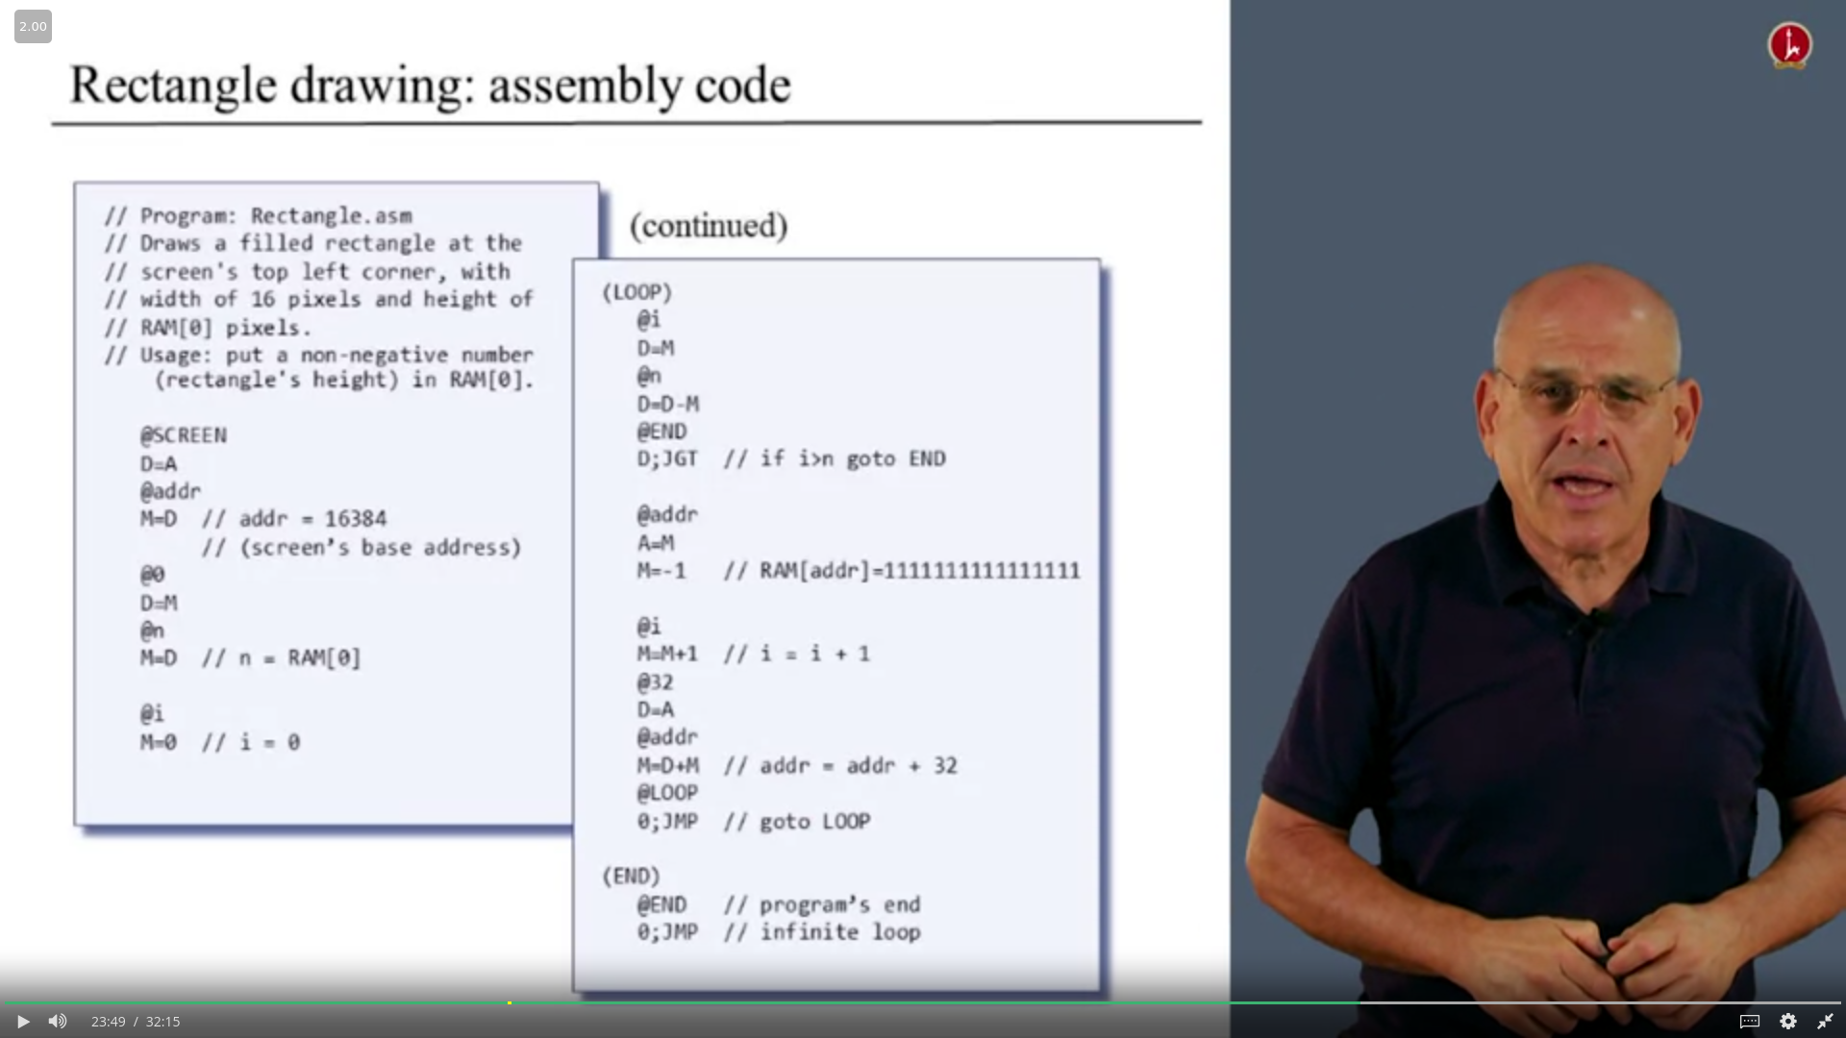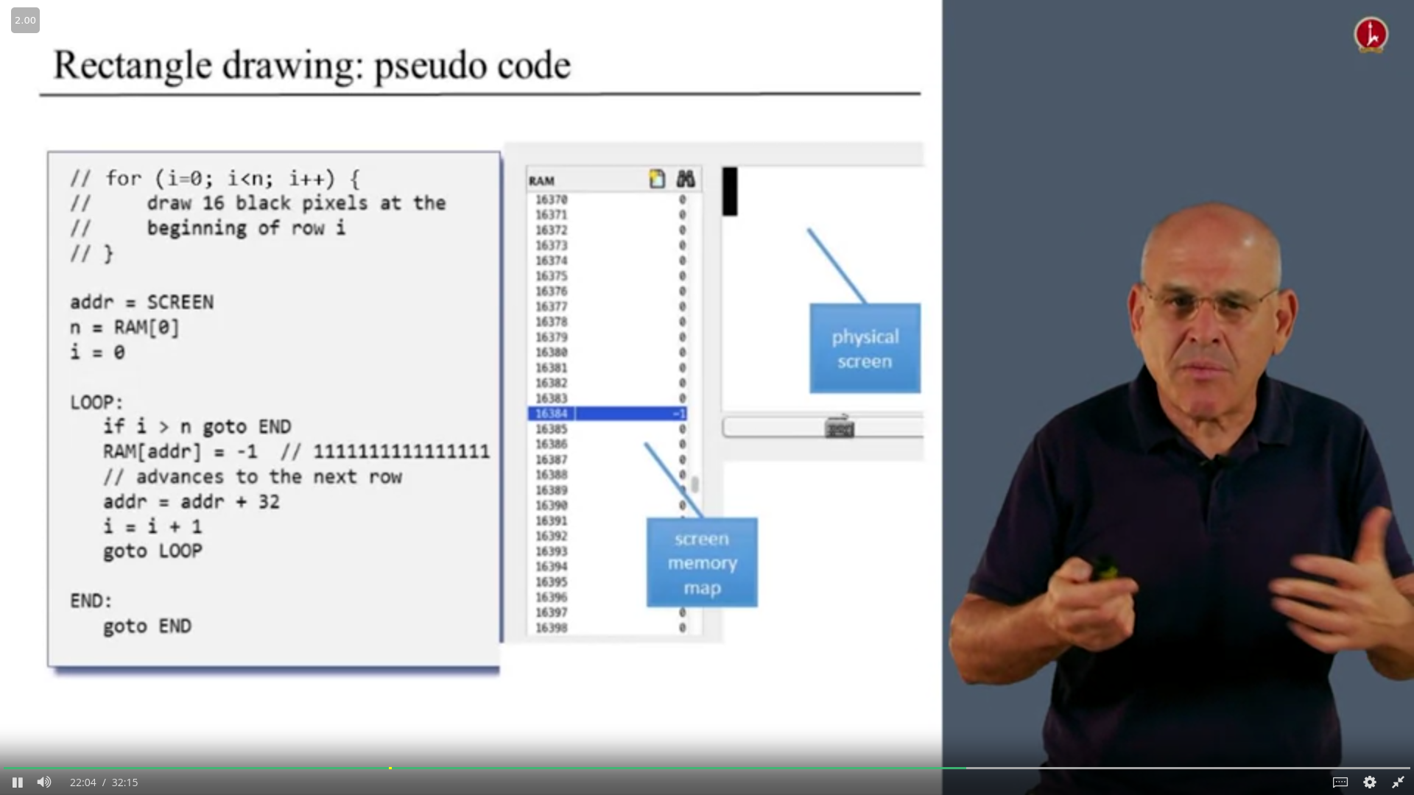

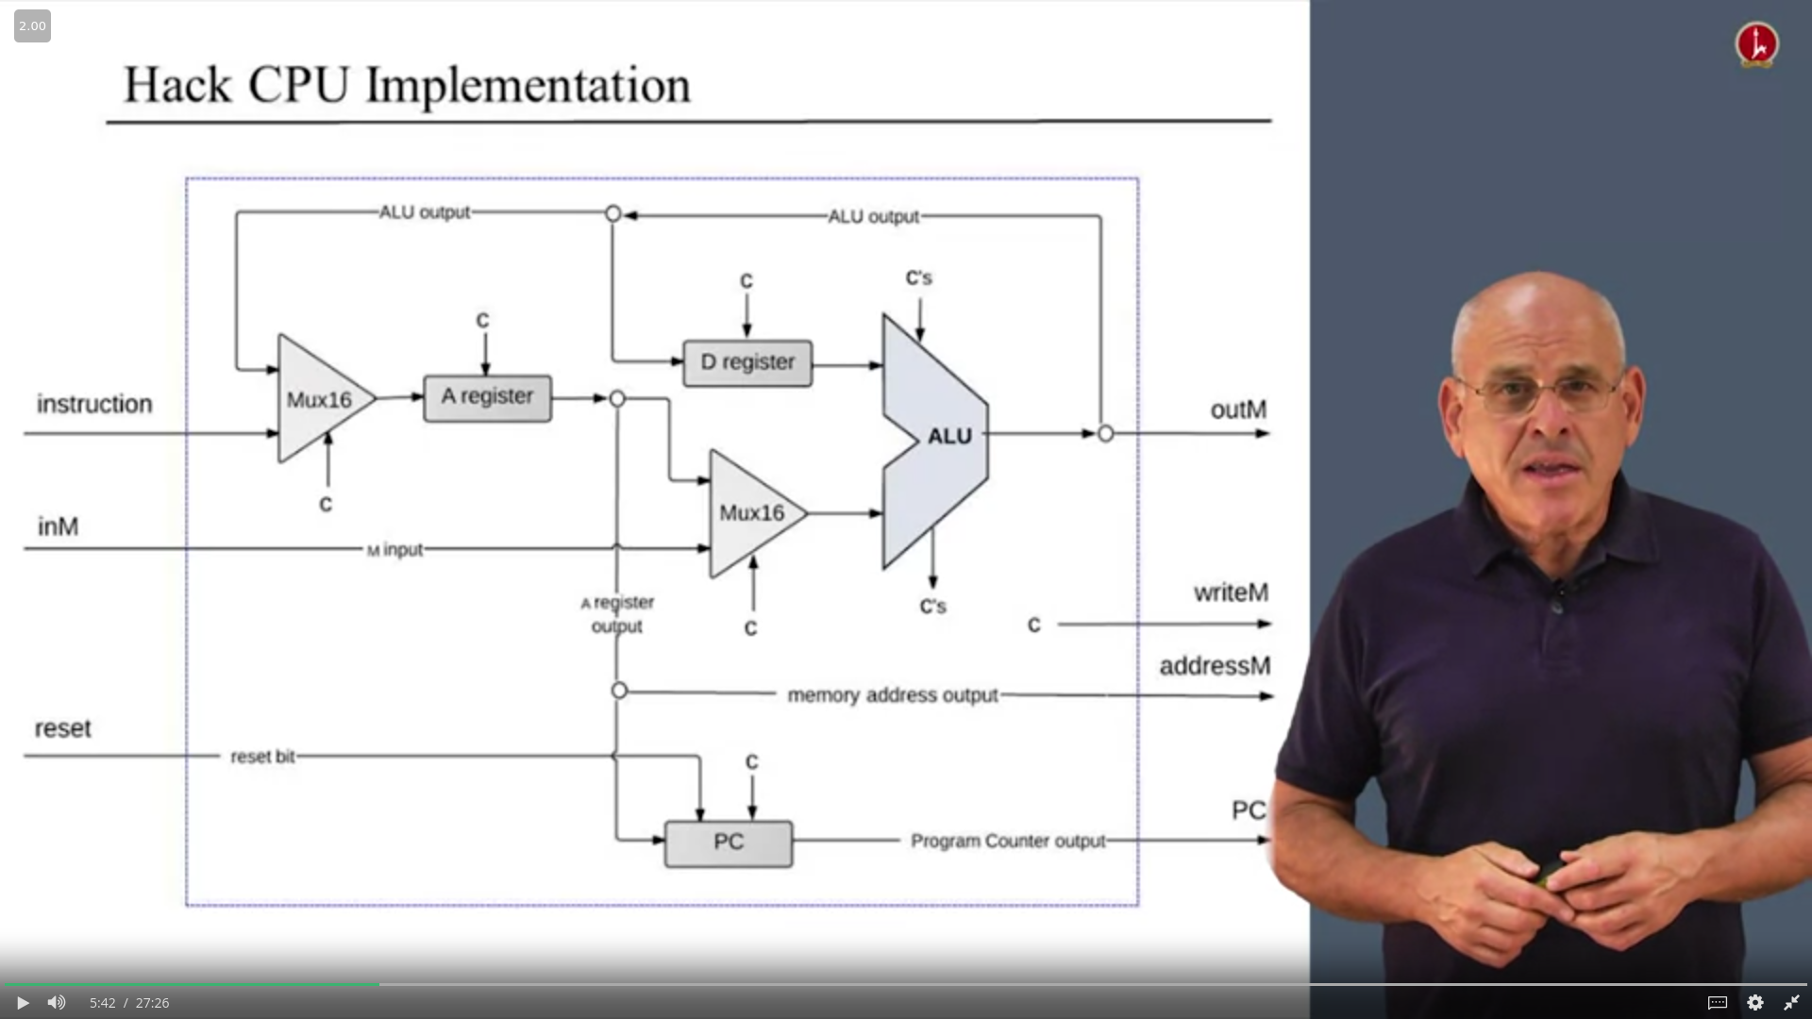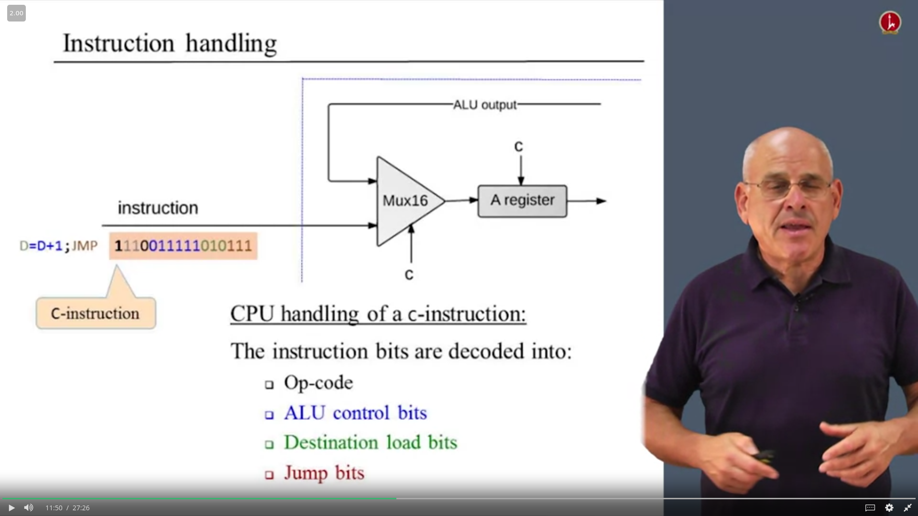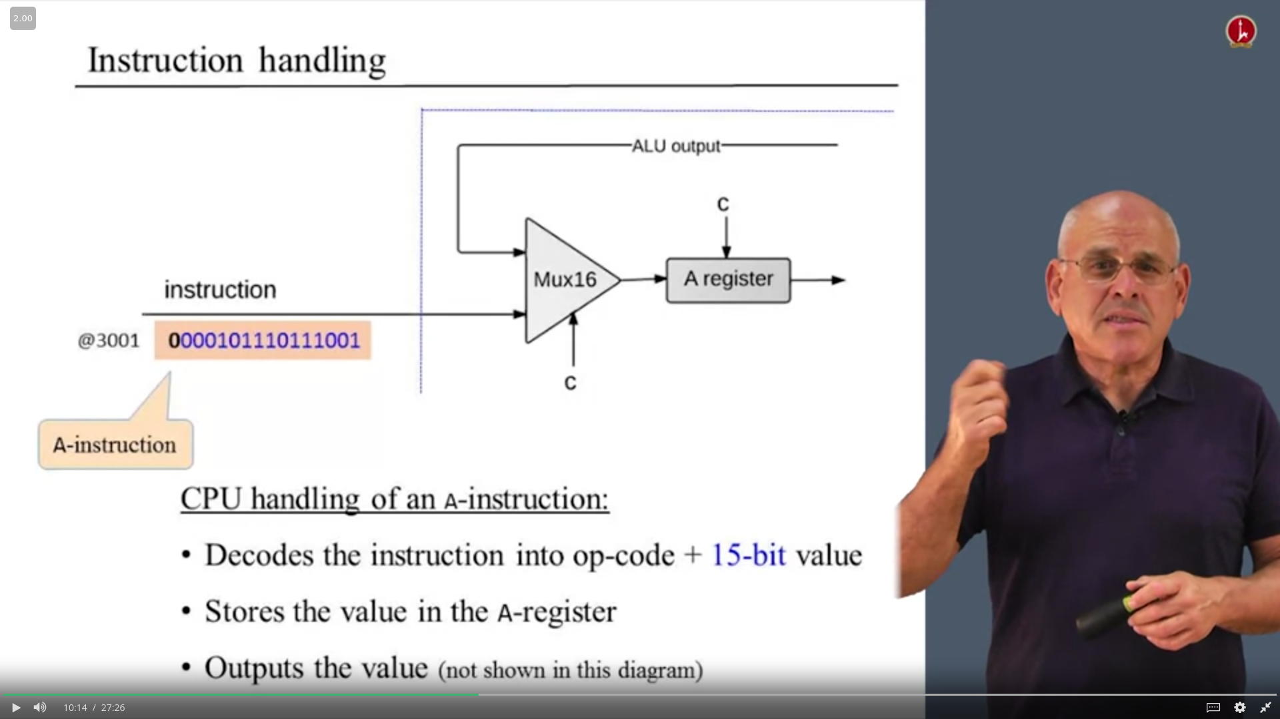

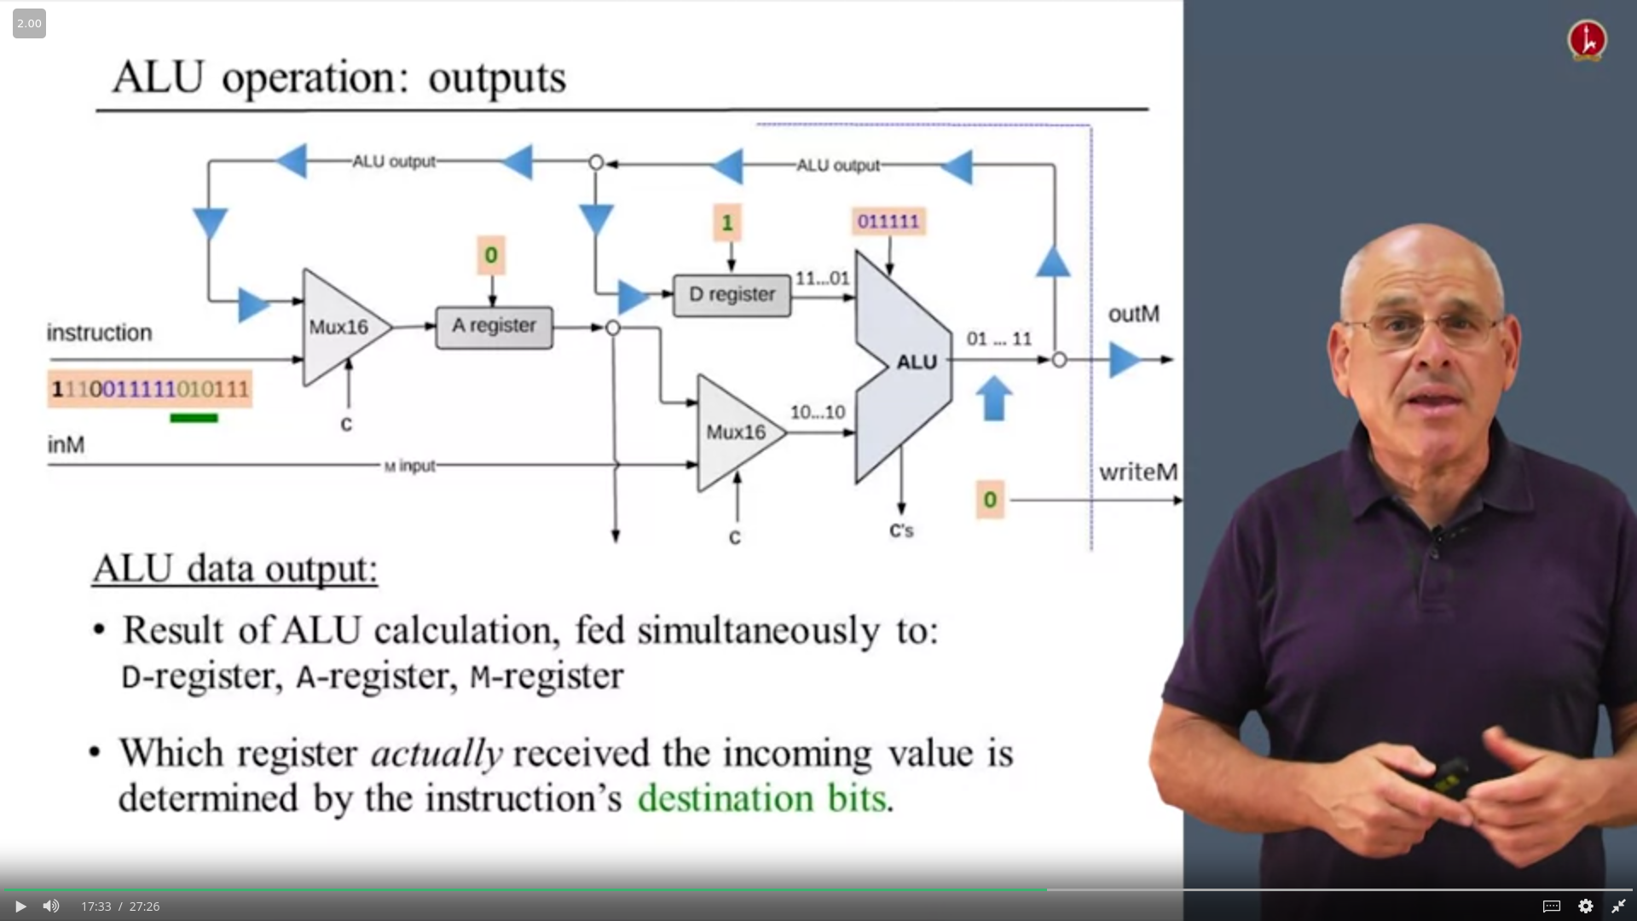

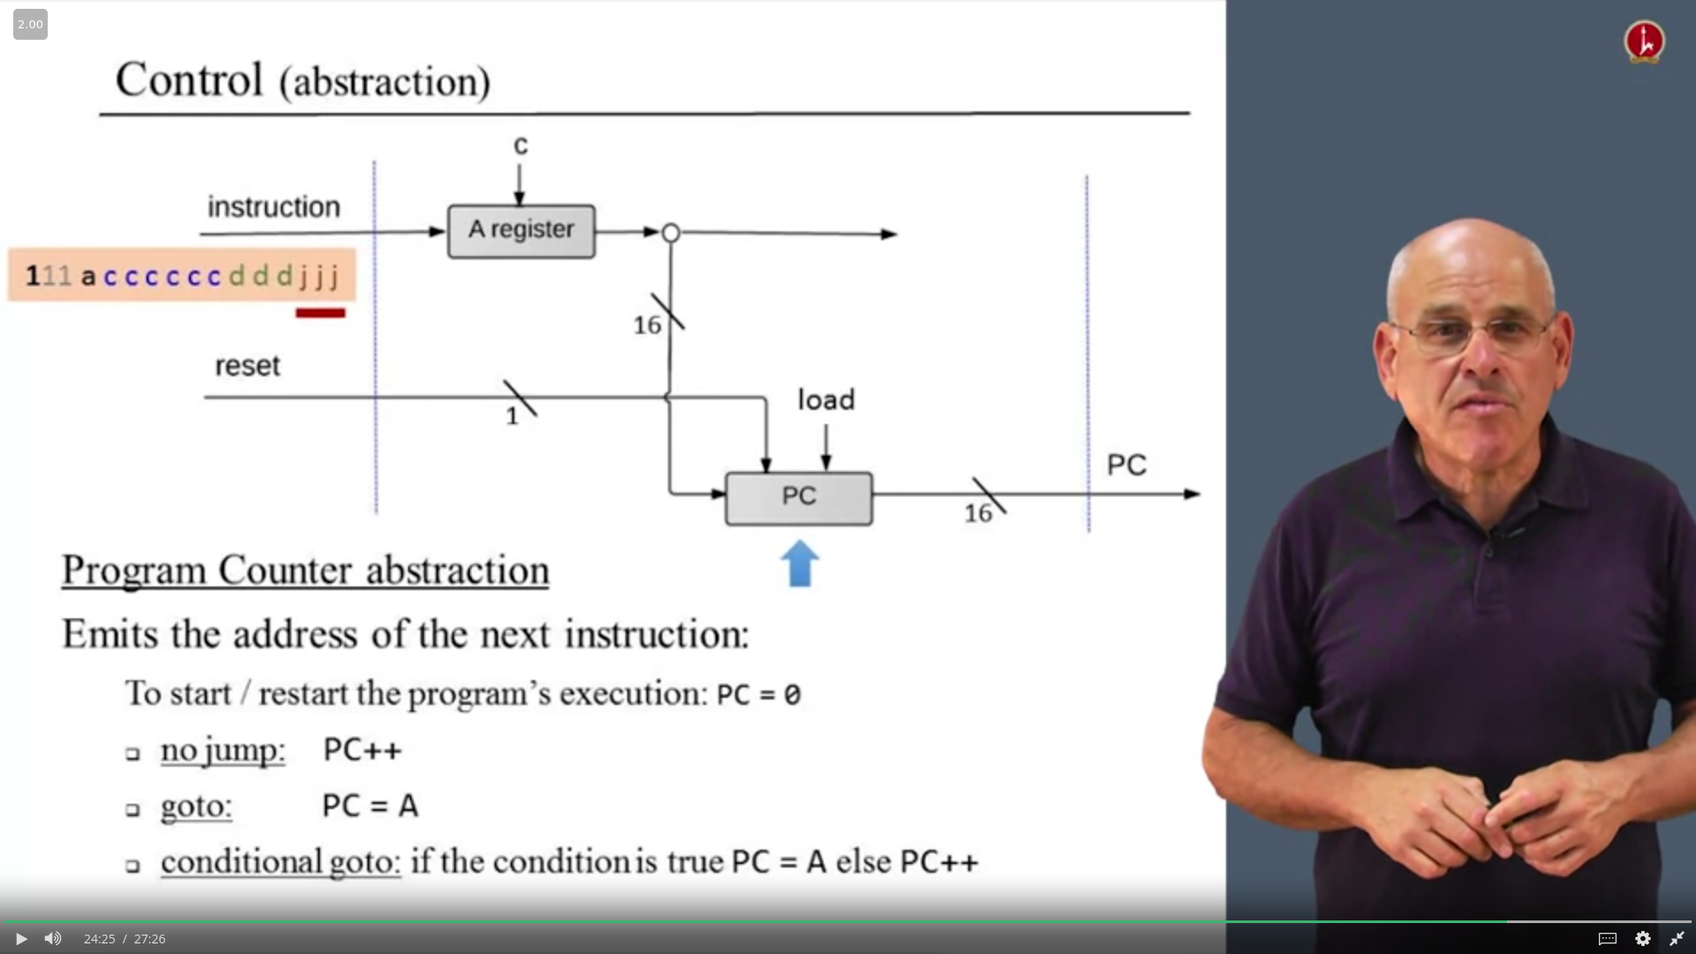

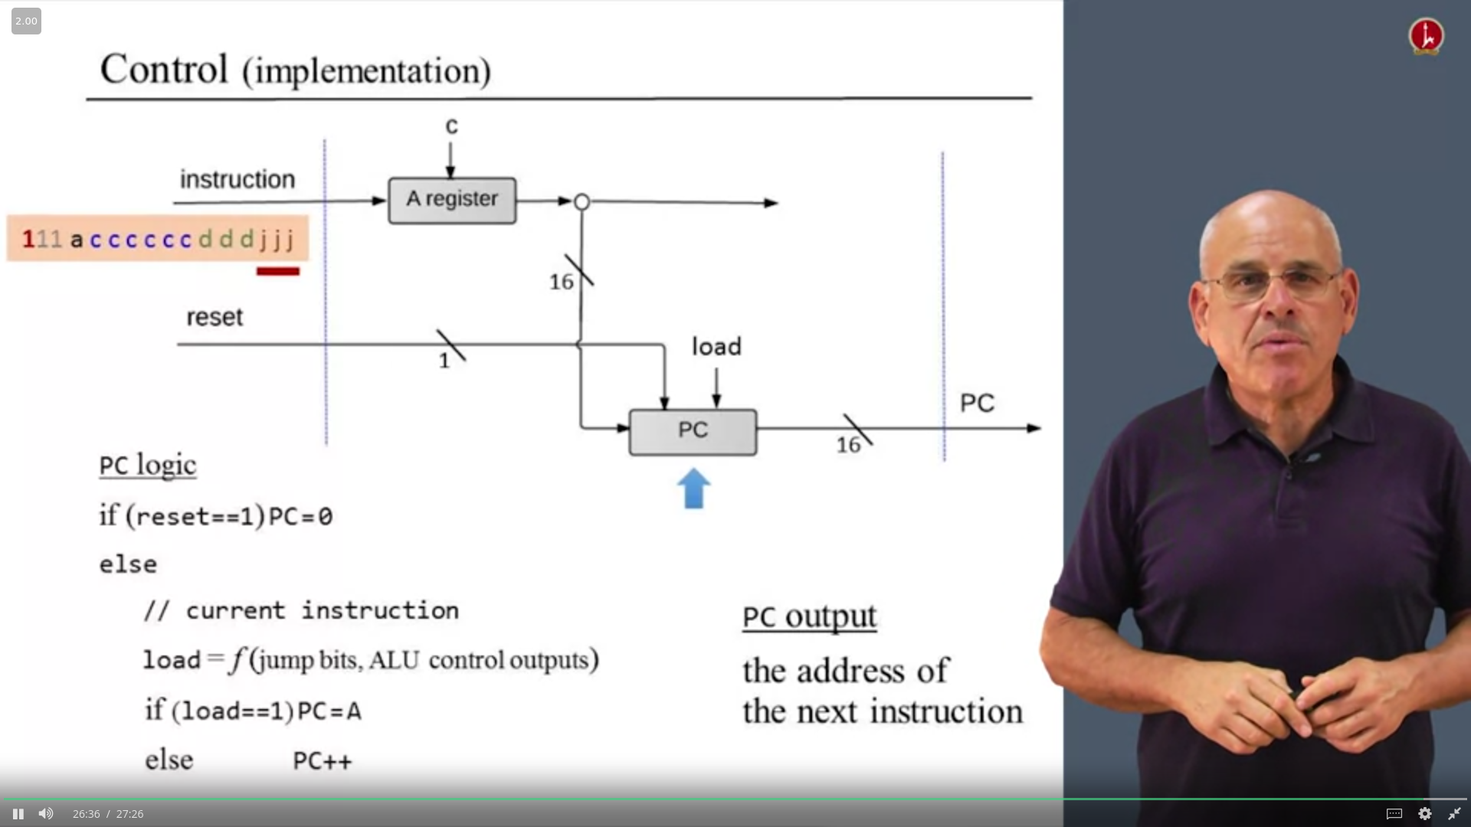

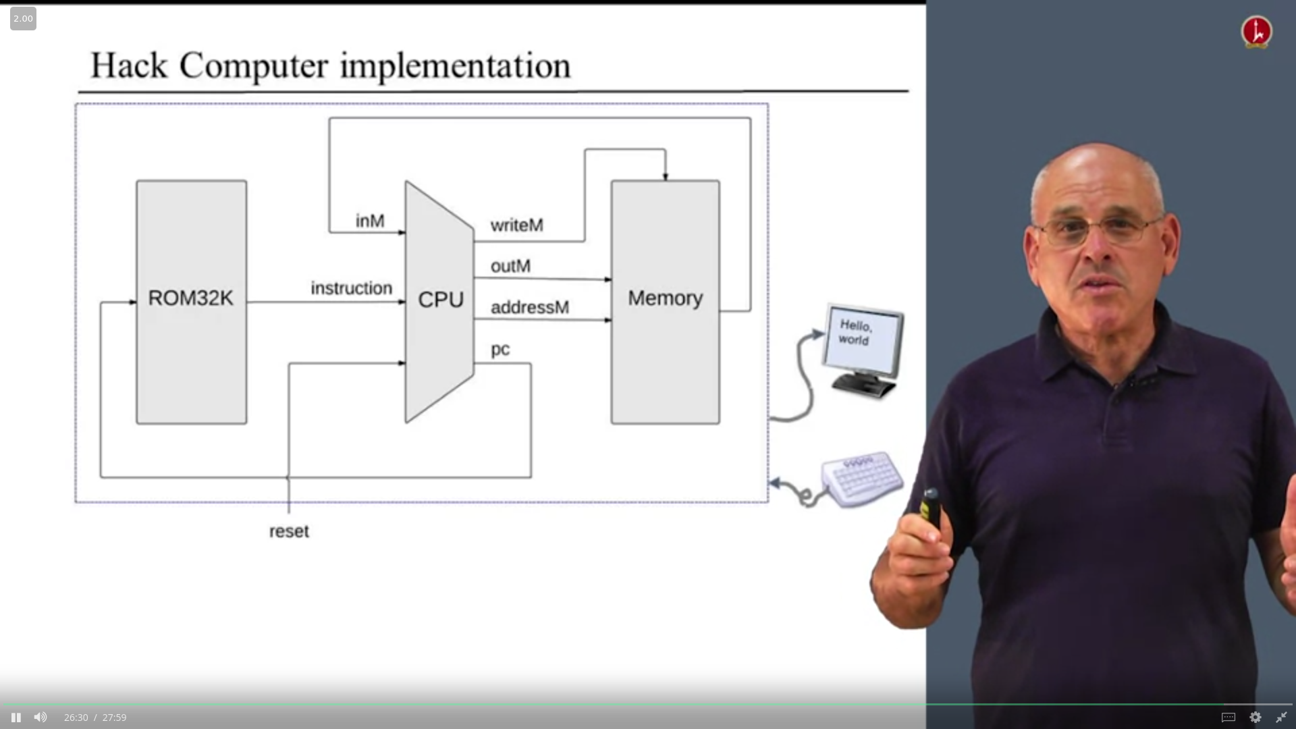

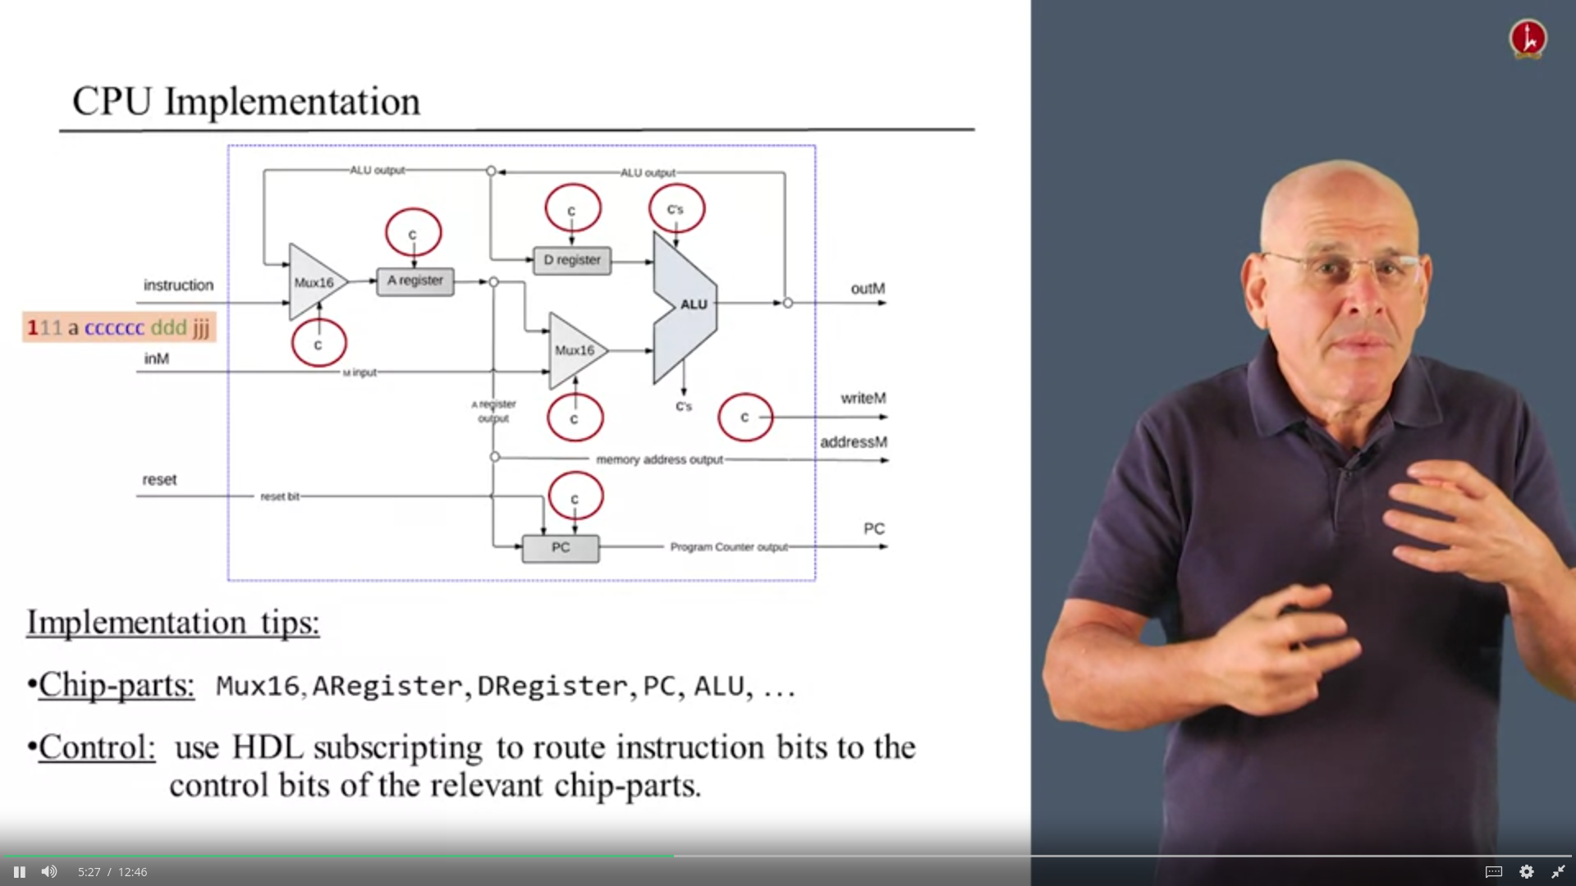

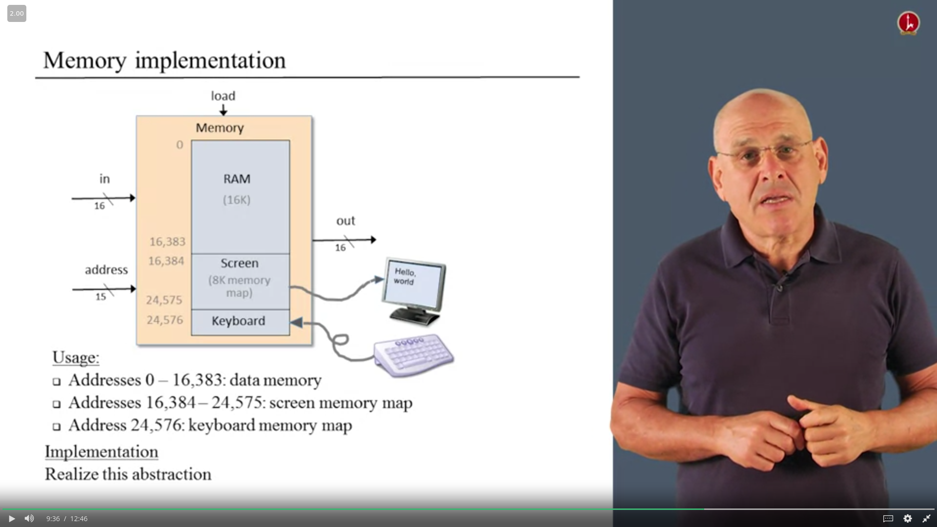

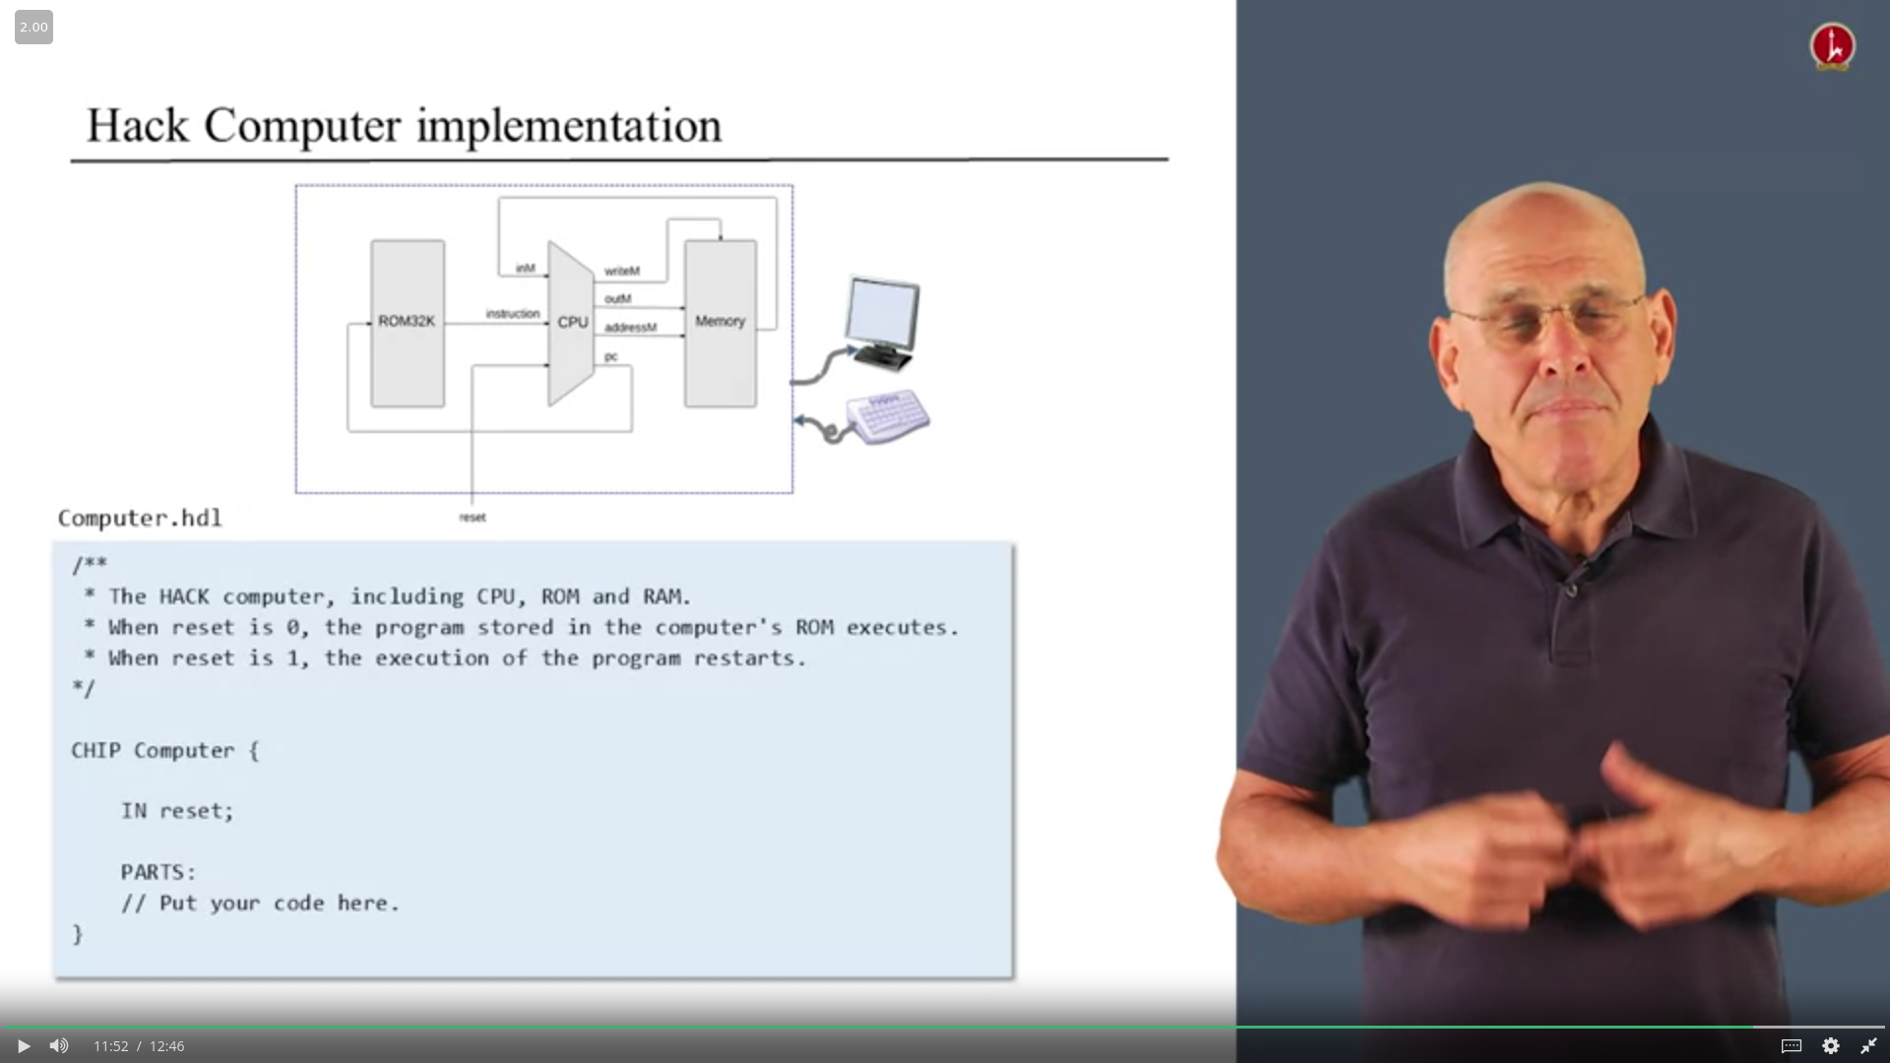

Well, in the, in our Hack computer, we had to separate,

read-only memory for the program and the separate data memory that was read-write.

Separating between these two different memories is sometimes

called the Harvard architecture and which I tend to view as just a flavor,

if you wish of Von Neumann architecture.

In a classic Von Neumann architecture,

you have a single memory that contains both the data and the program.

As we explained in the second unit of this week doing it the classical way has a tiny

complication that you need to separately fetch an instruction,

that is access a program instruction.

And separately at a different time at the next cycle,

execute the program which to, which to required for a, accessing the data memory.

In our Harvard architecture, we had the program in a separate memory unit.

Basically, we could do both of them in a single cycle, which made it a bit simpler.

Now this architecture, as is, is probably a very appropriate for

sometimes what's called embedded computers, where for computer does

a single thing that was pre-programmed to it and just put in to ROM.

A general purpose computer in which you want to keep on changing the program that

you run, you would probably need the full, real Von Neumann architecture.

The standard way of doing it is via the formalism of the finite machine.

A specification of the different things that the computer is supposed to do at

different times steps and how we're supposed to move from one statement to another.

Let me demonstrate.

Okay. So the idea is that for every possible state that the machine can be in, you have a type of circle and you have arrows between the different, different circles or between the different states of the machine that tell you, from which state do you move to which other state and why.

Complete the computer's construction in the following order:

​

Memory: This chip includes three chip-parts: RAM16K, Screen, and Keyboard. The Screen and the Keyboard are available as built-in chips, and thus there is no need to implement them. Although the RAM16K chip was built in Project 3, we recommend using its built-in version, as it provides a debugging-friendly GUI.

​

CPU: This chip can be constructed according to the proposed CPU implementation given in Figure 5.9 of Chapter 5, using the ALU and register chips built in Projects 2 and 3, respectively. We recommend though using built-in chip-parts instead, in particular ARegister and DRegister. The built-in versions of these two chips have exactly the same interface and functionality as those of the Register chip specified in Chapter 3; however, they feature GUI side-effects that come handy for testing purposes.

​

In principle, your CPU implementation may include internal chips of your own specification, i.e. chips not mentioned in Figure 5.9 of Chapter 5. However, this is not recommended, and will most likely yield a less efficient CPU design. If you choose to create new chips not mentioned in the book, be sure to document and unit-test them carefully before you plug them into the architecture.

​

Instruction memory: Use the built-in ROM32K chip.

​

Computer: The top-most Computer chip can be constructed according to the proposed implementation shown in Figure 5.10 of Chapter 5.

<http://www.32x8.com/sop5_____A-B-C-D-E_____m_4-10-11-12-14-15-17-20-21-25-26-27-28-29-30-31___________option-0_____999785965371826295733>

|  |  |  |  |  |  |
| --- | --- | --- | --- | --- | --- |
| j1 | j2 | j3 | zr | ng | load=inc not |
| 0 | 0 | 0 | x | x | 0 |
| 0 | 0 | 1 | 0 | 0 | 1 |
| 0 | 1 | 0 | 1 | x | 1 |
| 0 | 1 | 1 | 0 | 0 | 1 |
| 0 | 1 | 1 | 0 | 1 | 0 |
| 0 | 1 | 1 | 1 | 0 | 1 |
| 0 | 1 | 1 | 1 | 1 | 1 |
| 1 | 0 | 0 | 0 | 1 | 1 |
| 1 | 0 | 1 | 0 | x | 1 |
| 1 | 1 | 0 | 0 | 0 | 0 |
| 1 | 1 | 0 | 0 | 1 | 1 |
| 1 | 1 | 0 | 1 | 0 | 1 |
| 1 | 1 | 0 | 1 | 1 | 1 |
| 1 | 1 | 1 | x | x | 1 |

y = BD + CD'E' + AD'E

y=

if instruction[15]==0:

loadD=0

loadA=1

writeM=0

PC=inc

# ASSEMBLER

Repeat:

1. Read assembly language command
   1. Ignore whitespaces and comments
   2. Read the command into an array of characters
2. Break it into the different fields it is composed of
3. Lookup the binary code for each field
4. Combine these codes into a single machine language command
5. Output this machine language command

Until end of file reached

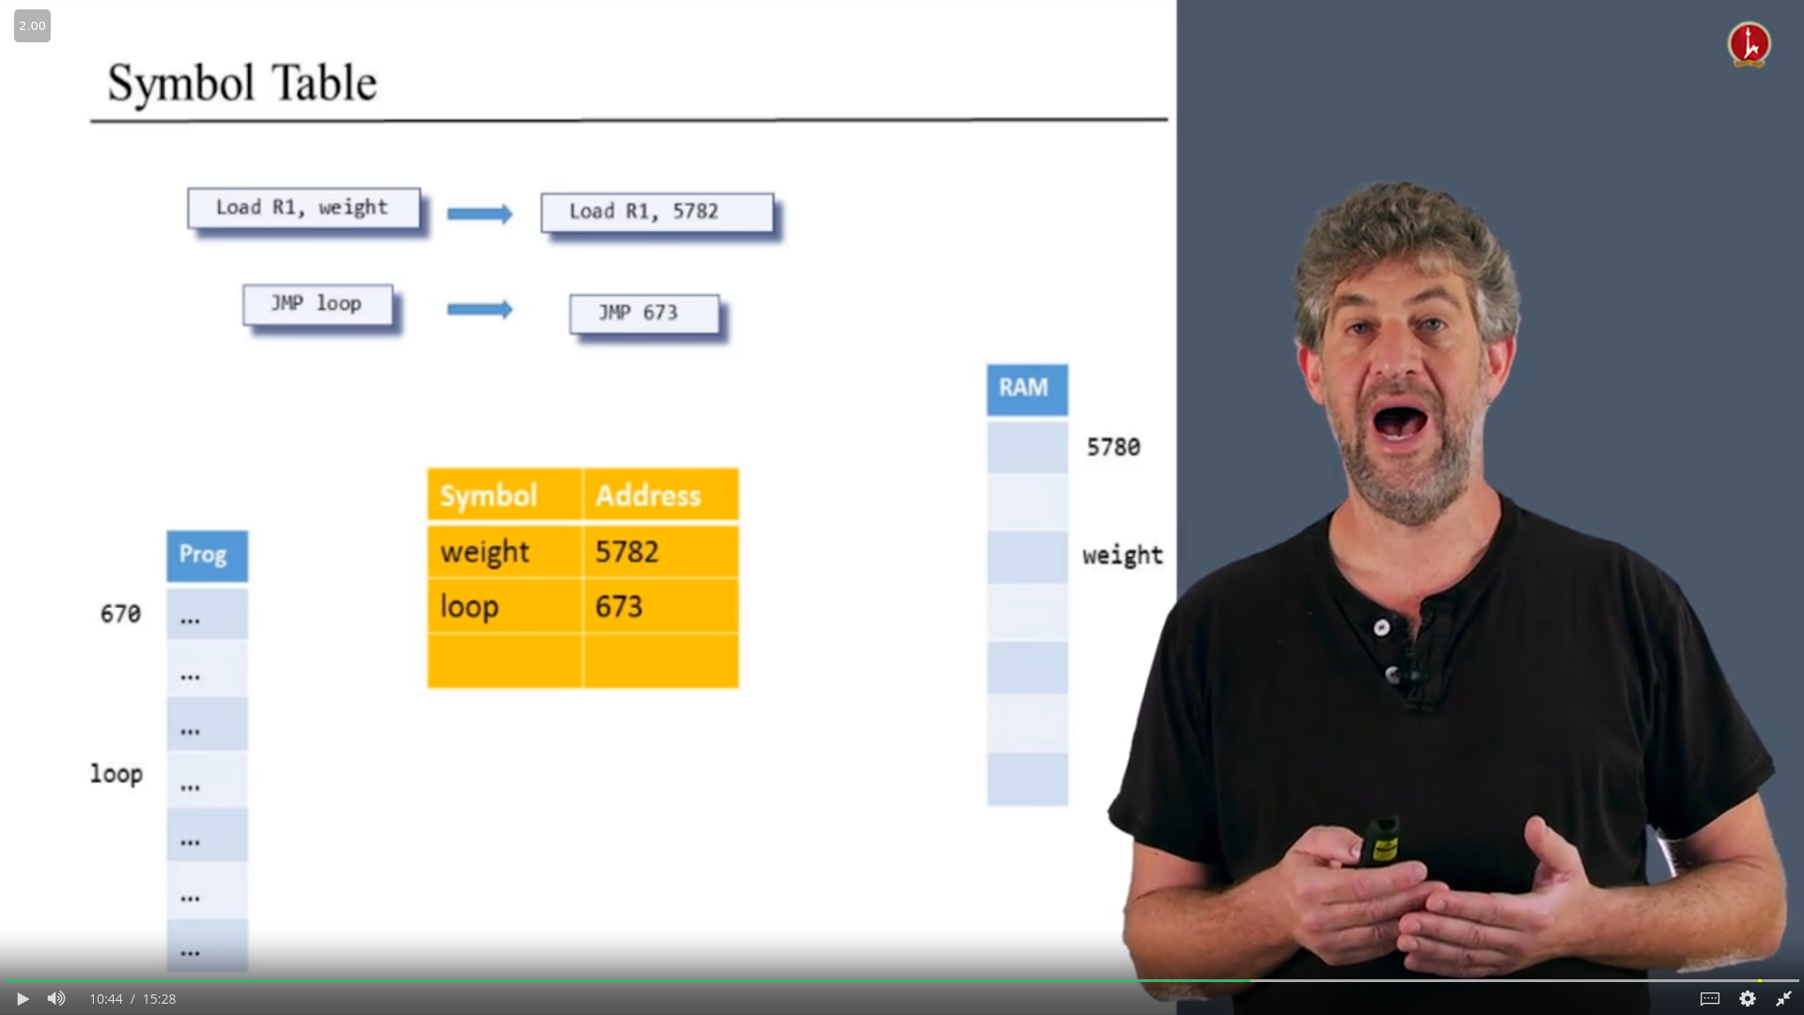

1. Find an unallocated memory space
2. Remember the address of label/command to execute
   1. Leave blank until label appears
   2. In first pass just figure out all addresses

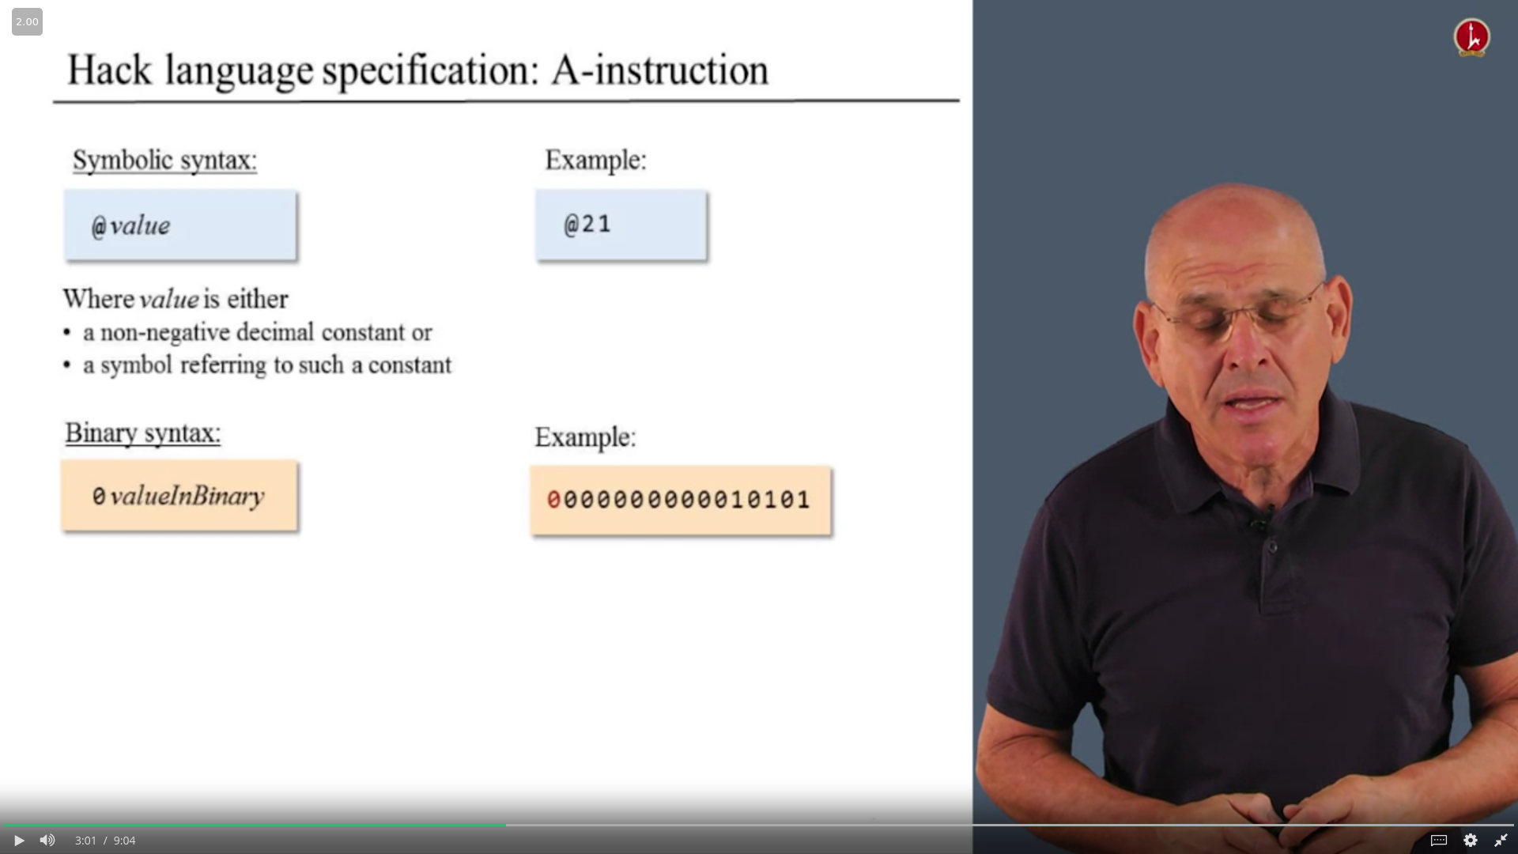

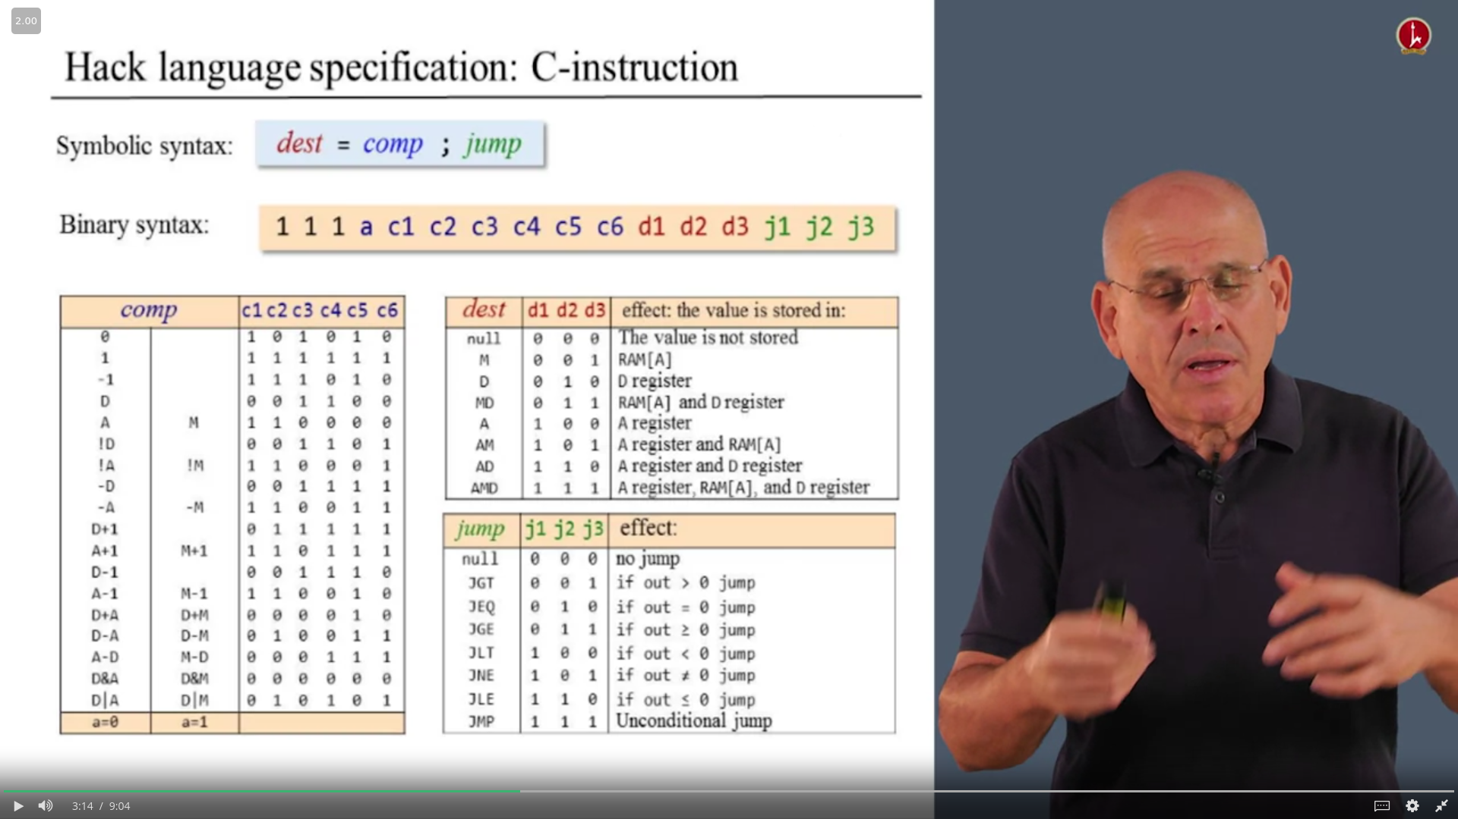

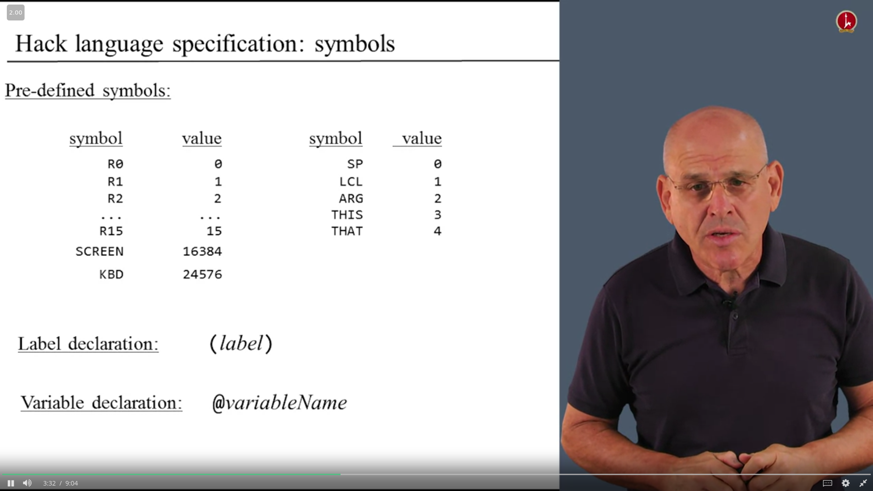

Functions

1. valueInBinary
2. parser => take source instruction and decompose it into 3 fields (for c instruction)
3. aInstruction
4. cInstruction
5. TableLookup => comp , destination , jump directive
6. Symbol Table

Symbols :

1. variable symbols

represent memory location where the programmer wants to maintain values . Each variable is assigned a unique memory address , starting at 16 . Replace variable symbol with value .

1. label symbols

represent destinations of goto instructions , the directive defines the symbol XXX to refer to the memory location holding the next instruction in program , keep track of line number while ignoring whitespaces and comments .

1. pre-defined symbols

represent special memory locations

